HWA CHONG INSTITUTION

C1 Physics
Time: 60 mins

Name: _________________ DATE: ________

CT: __________

Investigating the Motion of a Bouncing Ball using Video Tracker

Aim: To understand the motion of a bouncing ball

Procedure:

- Launch Software
Double click on the tracker.jar file. The screen should look like this.
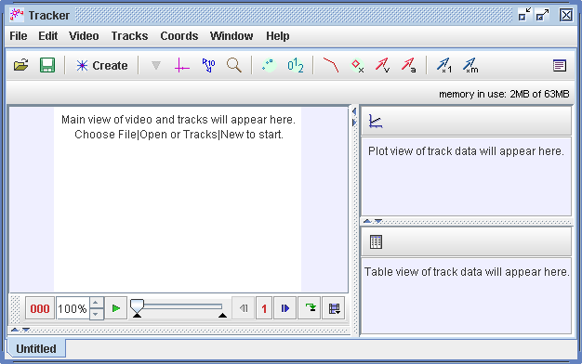

- Select Video to Analyse
Click the Open button or File|Open menu item and select the video “bouncingball”.

- Save Project
Click the ‘File’ menu and select ‘Save As’. Enter the filename as ‘bouncingball_<your name>’ eg ‘bouncingball_MaryTan’

- Zoom In or Zoom Out

In order to see the video more clearly, you may need to zoom in or out whenever necessary. Click the zoom icon for either zooming in (+) or out (-) and click on the video to see a larger or smaller view respectively. To see a fuller view of the bouncing ball, click zoom out (-) and click on the video. When you are done, click the zoom icon again until you see the magnifying glass without the ‘+’ or ‘-‘ sign.

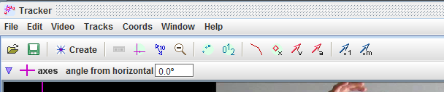

- Specify Clip to Analyse
Select the display of the clip settings by clicking the ‘Clip Settings’ button at the right end of the player as shown.
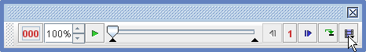
In the clip settings dialog, enter the start and end frames to specify the range of the video clip that you wish to analyze. In this video, set the start frame to be 2 (leave the rest as default). Click OK to proceed.
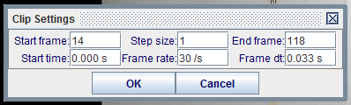

- Set Reference Frame
Click the Axes button to show the coordinate axes. Drag the origin (the intersection point) to the initial position of the object (choose a convenient point on the object).

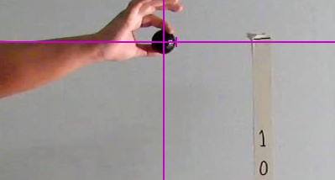

- Calibrate Scale of the Video
Click the Tape Measure button to show the tape. For this video, the vertical distance between the markings on the wall is 100.0 cm. Move, drag and/or rotate the tape to indicate the distance. Double click on the value of the tape to change the distance to 100.0 (unit is in cm).
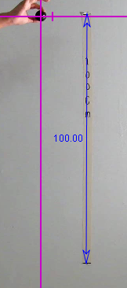

- Select Object Type
Click the Create button and choose a track type from the menu of choices. Select ‘Point Mass’.
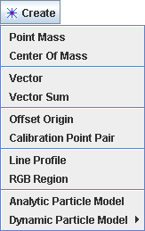

- Track Object

To track the object, mark its position on every frame by holding down the shift key (the cursor will change into a small box with a ‘+’ sign) and clicking the mouse as the video automatically steps through the video clip. Track the ball until the third time the ball touches the ground. You might need to scroll down the video (using the browser scroll ball) when you track the object.

Note: Do not skip frames, otherwise velocities and accelerations cannot be determined.
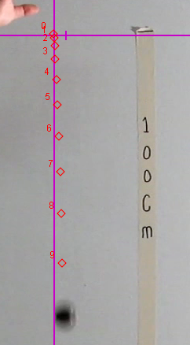

- Plot and Analyze Motion

If the graph area is hidden, click ‘Window’ from the menu and select ‘Right View’.

Click the ‘Plots’ button and select ‘3’. Below the graphs, you might see a window with the data values. You can drag down the window at its top margin so that all your three graphs are visible.

You can change the vertical axis by clicking the axis label. Change the axes to y-t, v_{y}-t and a_{y}-t, as shown below (your graphs should have the points being plotted).

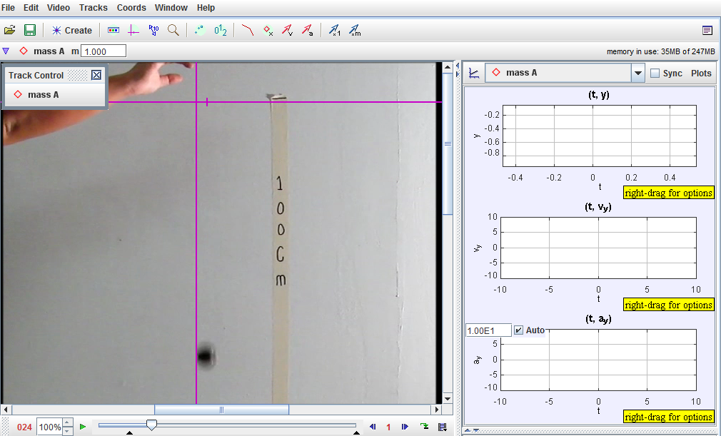

- Using the graphs that you have obtained, sketch the graphs of y-t, v_{y}-t and a_{y}-t. Identify and label the locations when
- the ball just touches the ground,
- the ball just leaves the ground and
- the ball is at its highest positions.

- Right-click on the a-t graph and select ‘Analyze’. You should see a pop-up window showing the graph a-t. Use the graph to complete the table below.

Sign Convention: Upwards as positive

 | Duration | Acceleration (includes both sign and magnitude)
1 | Immediately after being released to the time just before touching the ground for the first time
2 | Immediately after the first bounce to the time just before the second bounce
3 | Immediately after the second bounce to the time just before the third bounce
Average acceleration

- What can you conclude about the acceleration of the ball during the upward and downward motion between each bounce? Explain.

- Close the pop-up window. Right-click on the y-t graph and select ‘Analyze’. You should see a pop-up window. Again ensure that ‘Plot’ and ‘Fit’ are both checked, as shown below.

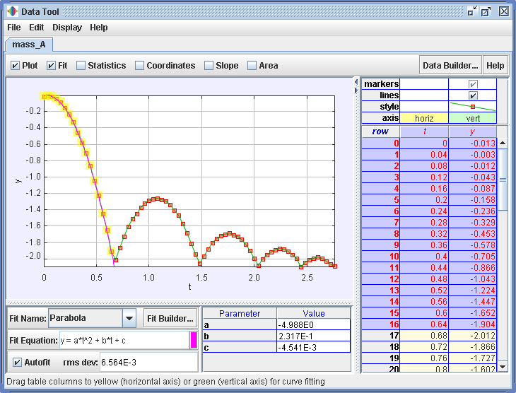

For the ‘Fit Name’ below the graph, select ‘Parabola’ and check ‘Autofit’ box.
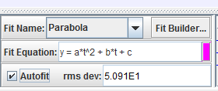

On the right table of the pop-up window, ensure that only the markers and lines for the y values are checked, and all others are unchecked, as shown below:

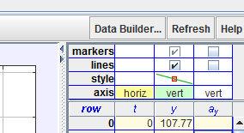

You will now need to select the range of values to fit the curve. Using the table, under the column ‘row’, click the first row that will fit the curve, hold down the shift key, and click the last row just before the ball touched the ground. The selected rows will be highlighted and the values of a, b and c will change accordingly.

Complete the table below.

 | Duration | Coefficient (parameter) |  |  | Equation of Graph (to include the coefficient values)
 | Duration | a | b | c | Equation of Graph (to include the coefficient values)
1 | Immediately after being released to the time just before touching the ground for the first time
2 | Immediately after the first bounce to the time just before the second bounce
3 | Immediately after the second bounce to the time just before the third bounce

- Repeat step 14 but analyse the vertical velocity (vy) of the ball instead. For velocity, select ‘line’ for the ‘Fit Name’.

Complete the table below using the technique mentioned.
 | Duration | Coefficient (parameter) |  | Equation of Graph (includes the coefficient values)
 | Duration | a | b | Equation of Graph (includes the coefficient values)
1 | Immediately after being released to the time just before touching the ground for the first time
2 | Immediately after the first bounce to the time just before the second bounce
3 | Immediately after the second bounce to the time just before the third bounce

- Describe three key concepts that you have learnt from analysing the motion of the bouncing ball.

- (optional) Explore how displacement varies with velocity and how kinetic energy varies with displacement.

