Video Tracker Worksheet

Aim: A quick hands-on Video Tracker experience

Procedure:

- Launch Software
Double click on the tracker_461.jar file. The screen should look like this.

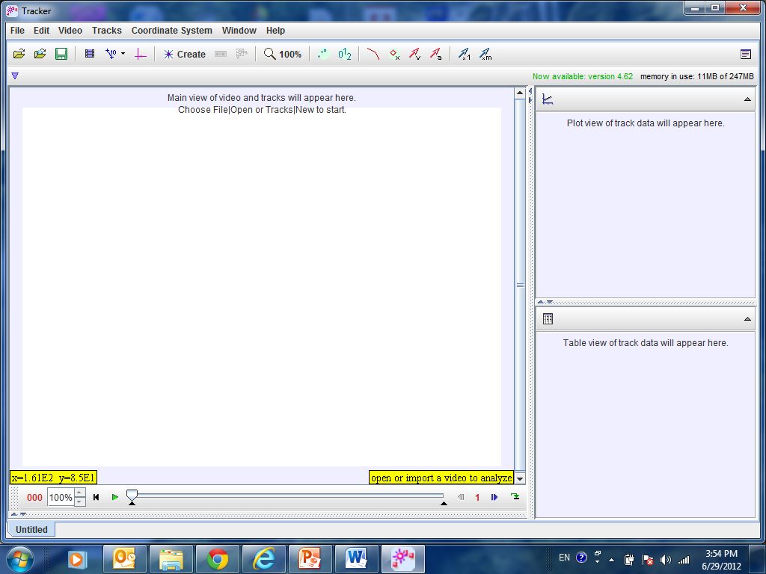

- Select Video to Analyse

Click the Open button or File|Open menu item and select the video “Rotating Fan.MOV”.

- Zoom In or Zoom Out

In order to see the video more clearly, you may need to zoom in or out whenever necessary. Click the zoom icon for either zooming in (+) or out (-) and click on the video to see a larger or smaller view respectively. Select 50% for this video.

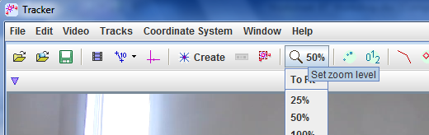

- Specify Clip to Analyse
Select the Clip Settings icon.
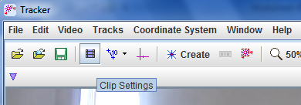
In the clip settings dialog, enter the start and end frames to specify the range of the video clip that you wish to analyze. In this video, set the Start frame at 0 and End frame at 100. Click OK to proceed.
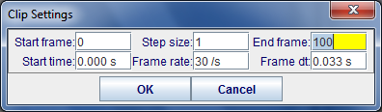
- Create Object
Click the Create icon and choose a track type from the menu of choices. Select ‘Point Mass’ for this video.
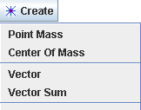

- Track Object

In this exercise, we will let the software auto-track the object.
Select the auto-tracker icon.

The auto-tracker dialog box (below) will appear.

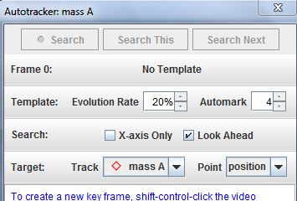

Create a new key frame by “shift-control-click” on the black dot located on the fan.

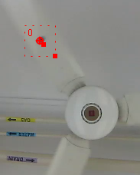

Make the tracker search box larger by re-sizing it using your mouse.

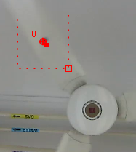

Select the Search Button to begin tracking.

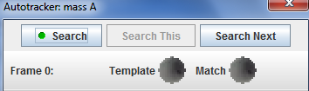

Select the Close Button when tracking is completed.

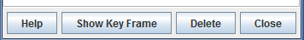

Note on manual tracking: To track the object manually, mark its position on every frame by holding down the shift key (the cursor will change into a small box with a ‘+’ sign) and clicking the mouse as the video automatically steps through the video clip. Note: Do not skip frames, otherwise velocities and accelerations cannot be determined.

- Plot and Analyze Motion

If the graph area is hidden, click ‘Window’ from the menu and select ‘Right View’.

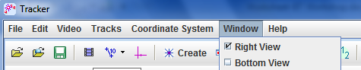

Can you see the x against t graph?

