2016 Learning Physics by Inquiry ICT Worksheet
Geostationary satellite

Name: | ……………………………………………………… | CG: …………………
Aim: To understand the characteristics of Geostationary Satellite.
Apparatus: Smart Phone/ Tablet with Gravitational eBook installed or use the simulation from http://goo.gl/09pJVL titled “Geostationary Orbit Model”

A geostationary (Earth) satellite is a satellite that rotates around Earth in a certain orbit such that it is always positioned above the same point on the Earth’s surface. The geostationary satellite must be placed 35 700 km from the Earth’s surface.

Carry out the following steps to understand the characteristics of a geostationary satellite.
- From the iBook/ Tablet: Scroll to 7.5.2 Geostationary Satellite – earth and satellite model in 3d java or go to the website http://goo.gl/09pJVL where you can play the simulation directly. This model allows you to visualise the motion of Earth rotating about its own axis and a satellite rotating around it.
- From your website, you can zoom in and out of the view on the screen by holding down the ‘shift’ key, while you ‘left-click & hold’ and move your mouse forward and backward. From iBook, you can “pinch” to zoom in and out
- You may also re-orientate your point of view on the model when you ‘left-click & hold’ and move your mouse forward and backward (without holding down the ‘shift’ key) until you get a clear 3D perspective as shown below. For iBook, hold and shift upward or downward to orientate your point of view.
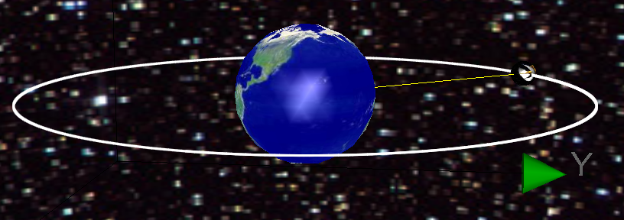
- You may check the box indicating “Equator Plane” as shown: 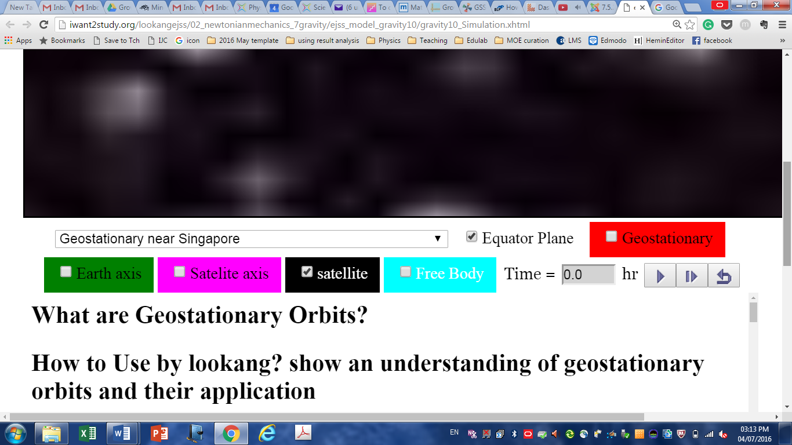 to display the equatorial plane of Earth.
- Check on the box “Satellite” to display the satellite
- You may check the Earth axis as shown: to display the axis of rotation for the Earth.
- You can select the mode of display by choosing from the drop-down meanu:
- However please note that before you change the mode of display, you need to pause the simulation by clicking button! To reset the simulation, you may click button.

Procedures | Observation and Answers
Mode 1: Select from the drop-down menu “Geostationary near Singapore”.  Play the simulation by clicking button and observe the relative positions of the satellite with respect to Singapore. | Watch how the ‘TIme’ changes. Observe the time for one complete orbit.
What do you notice about the relative positions of the satellite with respect to Singapore?
What is the period of rotation of the Earth about its own axis?
What is the period of rotation of the geostationary satellite?
Pause the simulation and check the Free Body button to display the forces acting on both Earth and satellite. What type of forces are these?
What do you notice about the magnitude and direction of the forces acting on Earth and on satellite (indicated by the length of arrow)? State a physics law that explains your answer.
State the force that is keeping the satellite in the circular orbit.

Procedures | Observation and Answers
Mode 2 Select from the drop-down menu “Geostationary near Africa”.
What do you notice about the relative positions of the satellites with respect to Africa and America?
Determine the periods of rotation of these geostationary satellites.
Hence why do you think the satellite is called a “geostationary satellite”, when the satellite is obviously not stationary?
Comment on the angular velocity of the geostationary satellite with respect to the angular velocity of the Earth’s rotation.

Procedures | Observation and Answers
Mode 3  Select from the drop-down menu “Non-geostationary due to direction”. Check the Geostationary button to display a sample geostationary satellite (in red). Click button and observe their motions. | Both satellites have periods equals to 24 hr.
What do you notice about the radius of the satellite’s orbit, compared to the radius of the geostationary orbit?
State the direction of rotation of the (red) geostationary satellite. | The direction of the red (geostationary) satellite is from (West/East) to (West/East).
State the direction of rotation of the other satellite. | The direction of the other satellite is from (West/East) to (West/East).
Does this other satellite stay directly above a fixed point on Earth?
Explain whether the other satellite is considered to be geostationary.

Procedures | Observation and Answers
Mode 4 Select from the drop-down menu “Non-geostationary circular motion at R = 3*Re”. This orbital radius is less than the radius of the sample geostationary (red) satellite orbit.  Click button. Observe the motion of the satellite. | The radius of the satellite’s orbit is shorter than that of the geostationary orbit.
Determine the period of rotation of the satellite.
Explain whether the other satellite is considered to be geostationary.
Mode 5 Select from the drop-down menu “Non-geostationary circular motion at R = 10.5*Re”. This orbital raidus is more than the radius of the sample geostationary (red) satellite orbit.  Click button. Observe the motion of the satellite. | The radius of the satellite’s orbit is greater than that of the geostationary orbit.
Determine the period of rotation of the satellite.
Explain whether the other satellite is considered to be geostationary.
Procedures | Observation and Answers
Mode 6
Select from the drop-down menu “Polar Orbits at R = 1.133 Re”. Click button. This is a satellite in polar orbit.
Observe the motion of this satellite and explain why this is called the polar orbit.
Explain whether the other satellite is considered to be geostationary.

Procedures | Observation and Answers
Mode 7
Select from the drop-down menu “Unlikely Orbits”. Make sure that you check the Free Body button .
Click button and observe the motion of this satellite carefully.
Does this satellite stay above a fixed point on Earth?
Is this kind of orbit possible?
Give a reason for your answer.
(Hint: Observe the direction of the force acting on the satellite.)
Having completed the above exercises, can you make some conclusions about the conditions for geostationary orbit?
Summarise the 3 conditions that must be satisfied for a satellite to be considered a geostationary satellite.
- ………………………………………………………………………………………..………………
- …………………………………………………………………………………………………..……
- ………………………………………………………………………………………………………..

--- End of worksheet ---

