2016 Learning Physics by Inquiry ICT Worksheet
Gravitational Field Strength (g) and Gravitational Potential (φ)

Name: | …………………………………………………..…… | CTG: …………………
Aims: (1) To understand the fundamental concepts of gravitational field strength (g), gravitational potential (φ) and how they vary with distance from the mass(es);
(2) To understand the relationship between g_{net} and φ_{net}.
Apparatus:
- Computer installed with Java runtime and the EJS java applet, titled “Gravitational field strength & potential Model”, which can be downloaded from LMS or from url:
https://dl.dropbox.com/u/44365627/lookangEJSworkspace/export/ejs_GField_and_Potential_1D_v7wee.jar

Gravitational forces exist between any two bodies of mass. Each body of mass naturally possesses a gravitational field of influence around itself. When two bodies of mass enter into each other’s gravitational fields, they are subjected to the influence of each other’s field strength.
Newton’s universal law of gravitation states that every particle attracts every other particle with a gravitational force that is directly proportional to the product of their masses and inversely proportional to the square of the separation r between their centres.
$$\left|F\right|=\frac{\text{GMm}}{r^{2}}$$
Q1 Open the above-mentioned EJS java applet. (Take note that for this simulation, when a value shows 1.23 E -8, it means 1.23 ×10⁻⁸)

Navigating the Easy Java Simulation (EJS)
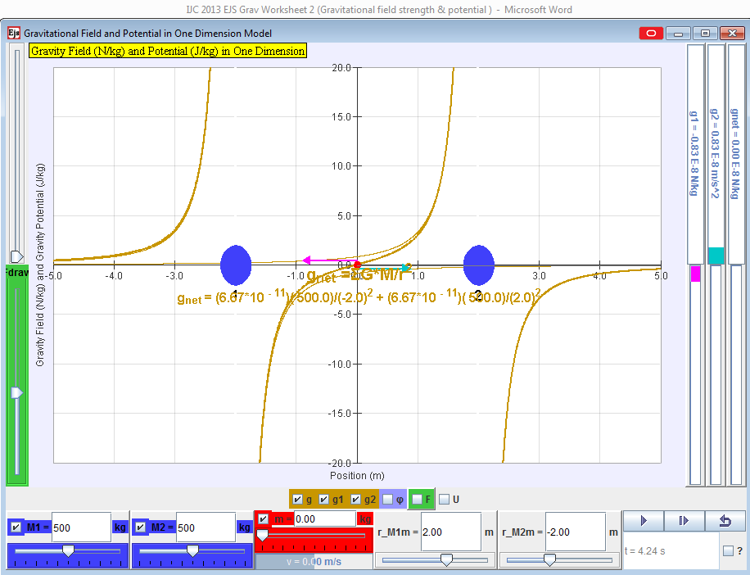
Bars to indicate magnitudes and directions of the various variables.
Force
scale
Y axis
Scale
g or φ
Mass M₁
Mass M₂
Test Mass m
Distance between m and M₁
Distance between m and M₂
Play to see how m moves.
To check for graph display g_{net}, g₁, g₂
φ_{net}, φ₁, φ₂

Reset
Test mass
M₂
M₁
- Gravitational field strength (g) due to a single source mass [20 min]

The gravitational field strength (g) at a point due the gravitational field (set up by a mass M) is the gravitational force per unit mass acting on a small test mass placed at that point.

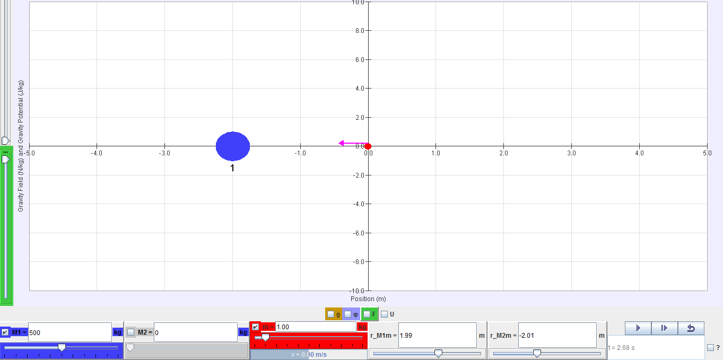

- Check the M1 button to display mass M1. Using the slider for M1, change the mass of M1 (blue ball) to 500 kg, as shown above.
- Check the test mass m button to display the test mass m (red dot). change the test mass to 1 kg, as shown above.
- The pink arrow acting on the test mass pointing towards M1 represents the field strength g1 of M1 acting on test mass. You may adjust the green ‘scale’ slider on the left side of the simulation to change the length scale of this arrow that represents g1.
- Click the button and watch what happens to the test mass and the arrow acting on it.
- “Left-click & hold” on the test mass (red dot) and move it around horizontally on both the left side and right side of M1. Observe the direction and magnitude of the arrow (representing the g1 by M1) acting on the test mass.

Observation (convention: take the direction to the right as positive)

Place the test mass 2.0 m to the left of M₁. | Place the test mass 2.0 m to the right of M₁.
The pink arrow is pointing to (left / right)  Thus, g has (positive / negative) value. | The pink arrow is pointing to (left / right)  Thus, g has (positive / negative) value.
As the test mass moves nearer to M1, the magnitude of arrow, and hence g, (increases / decreases). | As the test mass moves nearer to M1, the magnitude of arrow, and hence g, (increases / decreases).
Learning Points

Q2 Does g₁ have a constant magnitude at different positions around M1? If not, describe what happens to the magnitude when the test mass approaches M₁.
_________________________________________________________________________
No, the magnitude increases as the test mass is moved nearer to M₁.

Q3 Does g₁ have a constant direction at different positions around M1? Explain your answer. _________________________________________________________________________
No, the direction changes when the test mass is on different sides of M₁ because the field strength always point towards M₁.
_________________________________________________________________________
_________________________________________________________________________

Q4 Hence, state whether the gravitational field strength, g, is a vector or scalar quantity. _________________________________________________________________________
It is a vector quantity.

- Gravitational field strengths (g) due to two source masses [30 min]

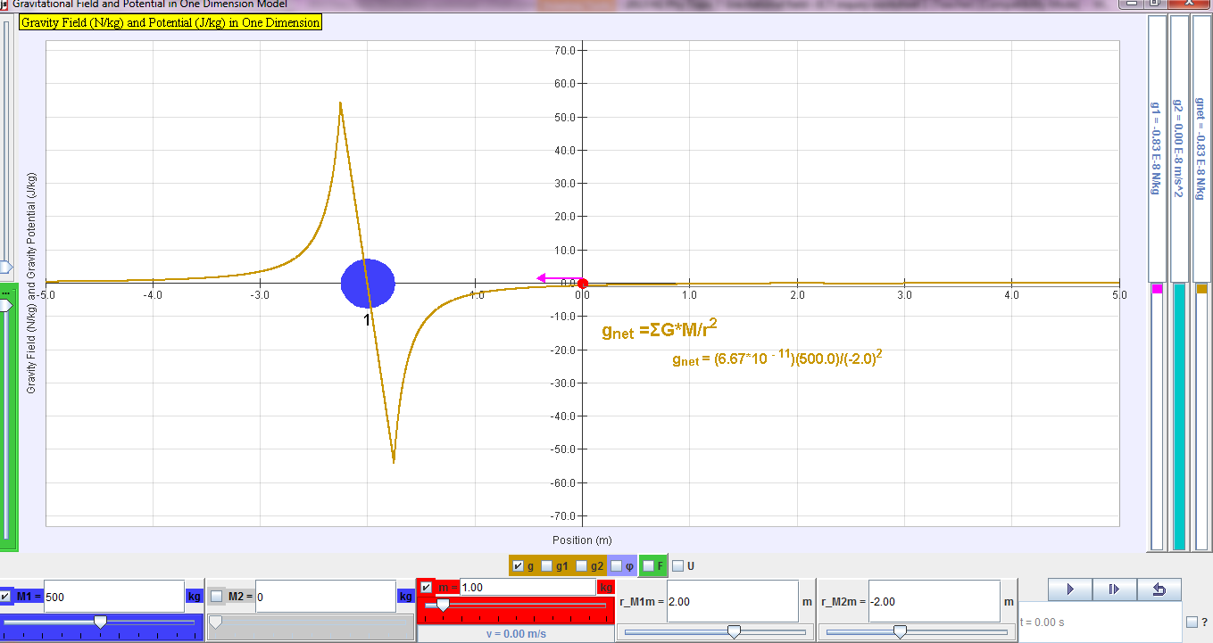

- Check the ‘g’ button to display the graph of M1’s gravitational field strength and the three field strength bars. These bars indicate the magnitude of the field strength (by the length of the colour bars) and the sign of the field strength (‘positive’ if the bar appears above the midpoint; ‘negative’ if the bar appears below the midpoint). “g1’ represent the field strength of M1, “g2” for M2 and “gnet” for the net field strength of both masses at the position of test mass.
- Move the test mass around and compare the shape of the graph with the g values.
- Uncheck M1 button. Check M2 button to display mass M₂ and adjust its mass to 500 kg. The graph showing the variation of field strength with distance from M₂ (g vs r graph) should apear.
- Move the test mass around again and compare the shape of the graph with the g values.
Q5 Sketch the individual g vs r graphs for M₁ & M₂ separately in graph 1 below. Use different colour pens to draw each graph.
g₂
g₁

M2
M1
r
r
Graph 1: Individual g vs r graphs for M₁ & M₂

Q6 Now predict how the net g vs r graph will look like if the two masses M₁ & M₂ appear simultaneously, side by side 4 m apart, in graph 2.

g_{net}
r
M1
M2
Graph 2: Net g vs r graph for M₁ & M₂ (both set at 500 kg)

- Check the boxes of both masses M₁ and M₂ and the combined g to show the values and graphs of g₁, g₂ and g_{net}. Check your prediction and correct your graph if it is wrong.
- Observe the two arrows (pink for g₁ and blue for g₂) acting on the test mass. Move the test mass around. Pay attention to how the two arrows change and compare the shape of the graph with the gnet values (net field strength by both M₁ & M₂).

Q7 Find the position where the two arrows point in opposite direction and have equal length. This is called the neutral point.
What is the g_{net} value at that point? Give a reason for your answer
_________________________________________________________________________
The net g value is zero at neutral point because the field strengths by M₁ and M₂ are of equal magnitude and opposite directions, hence cancelling each other.
_________________________________________________________________________
_________________________________________________________________________
Mark the neutral point N in graph 2. Predict what would happen to the test mass when you click the button. Check your prediction.
The test mass will stay stationary at that point.
_________________________________________________________________________

Q8 Predict what would happen to the neutral point in the net g vs r graph if the mass M₂ is reduced to 100 kg. Sketch your predicted graph in graph 3 and mark the new neutral point N’.
__________________________________________________________________________
The field strengths will have different magnitudes and hence net g will not be zero.
g_{net}
r
M1
M2
Graph 3: net g vs r graph for M₁ & M₂ (M₁= 500 kg; M₂= 100 kg )

Q9 Calculate the distance from M1 to the new neutral point N’. (Hint: g_{net} = 0)

2.75 m
Distance (based on calculation) = _________ m
Q10 Adjust the mass of M2 to 100 kg and check your prediction. Correct your graph if it is wrong. Move the test mass to the new neutral point and record the distance r_M1m from the simulation below. The distances from your calculation and the simulation should be the same!
2.75 m
Distance (based on simulation) = _________ m

C. Gravitational potential (φ) due to a single source mass [20 min]

Now we will look at another characteristic of gravitational field.
The gravitational potential (φ ) at a point due the gravitational field (set up by a mass M) is the work done per unit mass by an external agent in bringing a small test mass from infinity to that point.
- Uncheck the ‘g’ and M2 buttons. Ensure that the mass of M₁ is 500 kg.
- Check the φ (potential) button to display the graph showing the variation of potential with distance from mass M₁ (φ vs r graph).
- “Left-click & hold” on the test mass (red dot) and move it around horizontally again on the left and right side of mass M₁. This time, observe the potential, φ value of the test mass by M₁ (φ1) displayed on the potential bars on the right of the screen.
Q11 Is the gravitational potential, φ, a vector or scalar quantity? Give a reason for your answer. (Hint: refer to the definition of gravitational potential.)
Potential is a scalar quantity, since it is defined as work done.
_________________________________________________________________________
Q12 What happens to the φ₁ value when the test mass is placed further away from mass M₁.
_________________________________________________________________________
The value increases as the value becomes less negative.
Q13 According to the lecture notes, what is the value of φ₁ if the test mass reaches infinity? _________________________________________________________________________
The value will be zero at infinity.
Q14 Hence explain why the sign of gravitational potential is always negative, based on your answers in Q12 and Q13.
The potential value is always negative as the maximum value is zero at infinity and the value decreases as it is moved nearer to M₁.
_________________________________________________________________________
_________________________________________________________________________

D. Gravitational potential (φ) due to two source massES [10 min]
- Uncheck M1 button. Check M2 button to display mass M₂ and ensure its mass is 500 kg. The graph showing the variation of potential with distance from M₂ (φ vs r graph) should also apear.
- Move the test mass around again and compare the shape of the graph with the φ values.
Q15 Sketch the individual φ vs r graphs for M₁ & M₂ separately in graph 4 below. Use different colour pens to draw each graph.
Graph 4: Individual φ vs r graphs for M₁ & M₂
M2
φ₂
φ₁
M1
r
r

Q16 Now predict how the net φ vs r graph will look like if the two masses M₁ & M₂ appear simultaneously, side by side 4 m apart, in graph 5.

M1
M2
φ_{net}
r

Graph 5: Net φ vs r graph for M₁ & M₂ (both set at 500 kg)
- Check the boxes of both masses M₁ and M₂ and the combined φ to show the values and graphs of φ₁, φ₂ and φ_{net}. Check your prediction and correct your graph if it is wrong.

E. Understanding the relationship between gravitational field strength (g) and potential (φ) [20 min]
Q17 Check the dφ/dr button to display the tangent of the φ vs r graph and the value of dφ/dr. Also check the g vs r graph and strength bars. Move the test mass into the various positions listed below relative to origin (r = 0) and record the corresponding dφ/dr and g_{net} values in the table.

Position of test mass relative to the origin | dφ/dr | g_{net}
-1.0 | 2.92 x 10⁻⁸ | - 2.92 x 10⁻⁸
-0.5 | 0.96 x 10⁻⁸ | - 0.96 x 10⁻⁸
0.0 | 0.00 | 0.00
0.5 | - 0.96 x 10⁻⁸ | 0.96 x 10⁻⁸
1.0 | - 2.92 x 10⁻⁸ | 2.92 x 10⁻⁸

Describe the relationship between the numerical values of dφ/dr and g_{net}.
g_{net} = dφ/dr
________________________________________________________________________

What do you notice about the signs of dφ/dr and g_{net}?
________________________________________________________________________
The signs are opposite to each other.

Hence what does this imply about the relationship between φ vs r graph and g vs r graph?
________________________________________________________________________
The gradient of φ vs r graph is equal to the negative of g value.
________________________________________________________________________

Observe the simulation more carefully and deduce whether the net g field arrow is pointing in the direction of increasing φ potential or decreasing φ potential.
________________________________________________________________________
The net g field arrow is pointing in the direction of decreasing potential.
________________________________________________________________________

--- End of worksheet ---

