Name: _______________________ ( ) Class: __________ Date: ________

THERMAL PHYSICS
8. Kinetic Model of Matter (NEW)

• States of matter
• Kinetic model

(a) Compare the properties of solids, liquids and gases
(b) Describe qualitatively the molecular structure of solids, liquids and gases, relating their
properties to the forces and distances between molecules and to the motion of the molecules
(c) Describe the relationship between the motion of molecules and temperature

Kinetic Model of Matter.

1 The kinetic model of matter states that all matter is made up of tiny particles called a____ or mo________. They are in cont_______ and ran______ motion and possessing kin______ energy. These tiny particles are held together by inter_________ for______.

2 There are three common state of matter, namely s________, l________ and g____.
(There are 2 more, plasma state and Einstein-Bose condensate)

3 These 3 states have different ph________ properties which are related to their mol_______ properties

4 The table below compares the physical properties of solids, liquids and gases

Solid | Liquid | Gas
Fixed s_________ and fixed vo_____ | No fixed s______ but  F______ volume | No fixed s_______ and no fixed vo______
Incom | Incom__________ | Hi____ com_____
High d_______ | _______ density | _____ density
Need a large force to change s________

Usually h______ and
ri____

5 The table compare the molecular properties of solid, liquid and gas.

State of matter | Solid | Liquid | Gas
Arrangement of particles | Cl______ packed together in a re____  Pattern. | Lo________ packed  with sp_______ for movement | Very f___ apart compared to li_____ and solids
Motion of particles | Vi________ about their fi_____ positions | Move relatively fr____ but confined to the cont______(restricted translational & rotational motion)_____ | Move freely and ra_______  ( Free translational & rotational motion  )
Space between particles | Very small | Small but la______ than in solids | Much larger than in liquids and solids
Forces between  particles | Very str_____ attra_____ intermolecular forces | Strong attractive inte______ forces but weaker than in s_____ | W_____ (often ne______) attractive intermolecular forces
Kinetic energy | least

State of matter | Solid | Liquid | Gas
Shape | Has a fixed shape because the particles are held in fixed positions by _______ intermolecular forces of ___________ | Takes the shape of the container it occupies because the particles can m_____ about relatively f_______ | Takes the shape of the container it occupies because the particles can move about freely and ran______
Volume | Has a fixed volume at a constant temperature because the particles are held in fixed positions by strong intermolecular f______ of attraction. | Has a fixed volume at a constant temperature because the particles are held cl_____ together by strong intermolecular f______ of attraction. | Takes the volume of the container because the particles can move about fr____ and randomly
Density | Has a relatively high density because the particles are closely p_____ together, usually in a reg______  pattern | Has a relatively medium density because the particles are slightly fur____ apart than in solids | Have a relatively low density because the particles are very f___ apart
Compressibility | Incompressible because there is very l______ space between the particles | Incompressible because there is very l______ space between the particles | Compressible because there is a lot of s_____ between the particles

Kinetic theory to explain

1. Expansion in volume of a gas when heated.

When a gas is heated the ther_______ energy from the heat source is transferred to the molecules of the gas. The molecules then gains k_________ energy. This would results in the average speed of the molecules to in ____________. If the gas is allowed to expand, the average space between the particles would ________ due to the increased temperature.

2. Pressure of a gas in a container

The gas molecules which are moving at high sp______ would coll______ with the surface of the container and exert a f______ on it. The total force of collision over the a________ is the pressure acting.

CLASSWORK

1 Fig. 1 shows a syringe that contains gas at the same pressure as the air outside. The pistion moves freely along the cylinder without any friction. There is no gas escaping.
sealed end
cylinder
gas
piston

Fig. 1

As the syringe is heated from 20 ºC to 100 ºC, the piston moves outwards. It stops moving when the temperature is steady.

State how the value of each of the following quantities compare at 100 ºC, after the piston stops, with its value at 20 ºC.

For each quantity you should write greater, the same or less.

The average distance between the gas molecules
The pressure of the gas after the piston stops
The average speed of the gas
The frequency of the collisions between the gas molecules and the piston

2 Which line in the table describes the movement of particles in copper and in air at 30 ºC?

 | Movement of particles
 | copper | air
A | none | random
B | none | vibration
C | vibration | random  ( )
D | vibration | vibration

3 Some oxygen gas is sealed in a sealed container that has a constant volume.
What will happen to the oxygen molecules when the gas is cooled?

A | They will become more dense.
B | They will contract.
C | They will move further apart.  ( )
D | They will move more slowly.

9. Transfer of Thermal Energy

• Conduction
• Convection
• Radiation

(a) Show understanding that thermal energy is transferred from a region of higher temperature to a region of lower temperature
(b) Describe, in molecular terms, how energy transfer occurs in solids
(c) Describe, in terms of density changes, convection in fluids
(d) Explain that energy transfer of a body by radiation does not require a material medium and the rate of energy transfer is affected by:
(i) colour and texture of the surface
(ii) surface temperature
(iii) surface area
(e) Apply the concept of thermal energy transfer to everyday applications

Notes
1 What is heat transfer?
It refers to the n___ transfer of heat e________ from h____ regions to c______. This law is also known as Zeroth Law of thermodynamics. There are _______ methods of heat transfer.

2 What is conduction?
It is the transfer of th________ energy through a m_________ without any mov_____ of the medium.

Conduction occurs as a consequence of excess energy of v___________ being passed along from atom to a____ in all so_______.
In all m_______, excess k_______ energy given to f_____ electrons near the source of heat is being carried by these electrons as they dif_________ towards col______ regions. This energy is converted back to vi_____________ energy when electrons col_____ with atoms. This mechanism is known as free electron diffusion. Conduction in liquids and gases is not efficient because the particles are spaced f_________ apart than those in solids. Also there is lesser co__________ between the particles present resulting in slower transfer of k______ energy.

3 What is convection?
It is the transfer of thermal energy by means of c___________ currents in a f______ (liquid or gas), due to a difference in d________. Convection current do not occurs in s______.

4 What is radiation?
It is the transfer of energy in the form of electromagnetic waves such as in________ radiation
without requiring a m_______.

5 The factors affecting the rate of emission and absorption of infrared radiation are

1. Co______ and tex_______ of the surface
2. Surface tem_______
3. Surface ar_______.
Applications of Thermal Energy Transfer.

Good conductors of heat are used in cooking utensils, soldering iron rods and heat exchange.

Kettles, saucepans and boilers are usually made of al_________ or sta_______st_____ where thermal energy is transferred quickly through the metal.

Poor conductors of heat (in__________) are used to pr_______ thermal energy being transferred quickly. Insulators can prevent inj_____ and damage in the application of h_________ of uten____ and appliances and in table mats. Another function of insulator is the ability to reduce heat loss ____. Examples would include clothing for _________ weather, d______ glazed windows and saw d____ used to cover ice blocks and polys______ foam in the walls of refrigerator

Common applications of convections
Electric kettles, Household hot water systems and Air Conditioners

Common application of radiation
Green Houses, Vacuum Flask

Classwork
1 Explain why the tip of the soldering iron rod is made of copper instead of steel.

____________________________________________________________________________

2 A heat pipe is a device that transmits thermal energy along its length. It can transmit energy thousands of times faster than a solid copper rod. Fig. 9.1 shows a heat pipe attached to black metal fins. The ﬁns absorb energy from the Sun. The sealed pipe transmits this energy along its length into a tank of
cold water
. 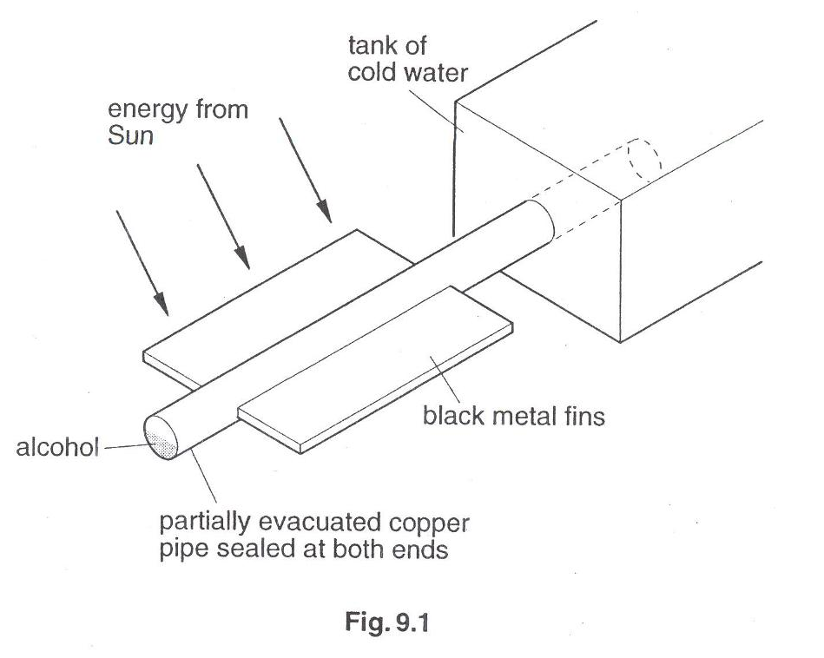
Fig. 2.1
Thermal energy from the fins is conducted through the walls of the copper pipe and causes the alcohol to boil. The boiling creates a higher pressure. At the end of the copper pipe in contact with cold water, the alcohol condenses and creates a lower pressure. The liquid alcohol runs along the pipe to be boiled again. There is little change in the temperature of the alcohol.

(a) Describe how molecules in the copper conduct energy to the alcohol. [1]

(b) Explain how boiling and condensation within the heat pipe cause the transfer of energy.

(b) Explain why the heat pipe is able to transfer energy at a fast rate. [1]
_______________________________________________________________________

10. Thermal Properties of Matter

• Internal energy
• Melting, boiling and evaporation

(a) Describe a rise in temperature of a body in terms of an increase in its internal energy (random thermal energy)
(b) Describe melting/solidification and boiling/condensation as processes of energy transfer
without a change in temperature (c) explain the difference between boiling and evaporation

7 Fig. 7.1 shows the cooling system of a car radiator where water is used as the coolant.

outflow pipe
fan draws air through radiator
cap
thermostat
pump
water jacket
radiator
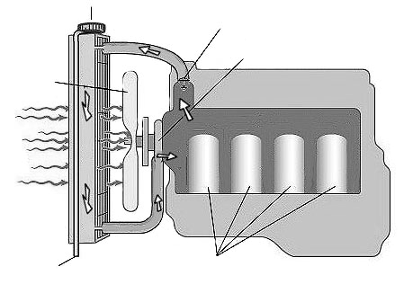

airflow

engine

Fig. 7.1

The engine is surrounded by a water jacket. When the water in the jacket is heated, it flows upwards into the radiator where it is cooled by the flowing air. The cooled water flows down and returns back to the jacket through a water pump.

(a) Describe how the rotating fan draws air through the radiator. [2]

(b) Explain why the radiator is made from aluminium and is painted black. [2]

3 | The figure illustrates the structure of a solar heating system.  hot water tank  solar radiation  absorption panel containing water pipes  glass cover  expanded polystyrene
 | (a) | By what process does the hot water rise up the water pipes? Explain why this process occurs.
 | (b) | Explain why the system is more effective when  (i) the surface of the absorption panel is blackened,  (ii) expanded polystyrene is used as the backing board.

