Assignment 10
Thermal Transfer

Name: __________________ ( ) Class: 3/____ Date: _______ Mark: _____/64
Section A (MCQ)

1 Three blocks, at temperatures T₁, T₂ and T₃, are in good thermal contact.
T₁
T₂
T₃
block 1 block 2 block 3

At which temperatures are the blocks in thermal equilibrium? ( )
 | T₁/°C | T₂/°C | T₃/°C
A | 300 | 20 | 30
B | 30 | 30 | 30
C | 30 | 40 | 30
D | 40 | 30 | 20

2 The heat from the hot water in a metal radiator passes through the metal and then spreads
around the room.

What are the main processes by which the heat is transferred through the radiator and then
spread around the room? ( )
 | through the metal radiator | around the room
A | conduction | conduction
B | conduction | convection
C | radiation | conduction
D | radiation | convection

3 Four metal cans are identical except for the colour and texture of their outer surfaces.
100 cm³ of water at 70°C is poured into each can.

Which can cools most rapidly? ( )

A
B
C
D
outer black, black, white,white,
surfacerough shiny roughshiny

4 Four bars, all exactly the same size, are each placed with one end in boiling water.
The times taken for the temperature of the other end to increase by 2°C are measured.
material of bar | time for 2 °C rise /s
aluminium | 10
copper | 5
cork | 800
styrofoam | 1200

To make a large metal tank with the least heat loss, which materials should be used for the
tank and its insulation? ( )

 | tank | insulation
A | aluminium | cork
B | aluminium | styrofoam
C | copper | cork
D | copper | styrofoam

5 How is heat transferred through the base of a metal saucepan? ( )
A | by conduction only
B | by radiation only
C | by conduction and convection
D | By convection and radiation

6 A cook makes the pudding ‘baked Alaska’.
The pudding is placed in a very hot oven until the top of the egg whites turns brown. It is then removed from the oven.

Why does the ice cream stay cold? ( )
A | Air is a good conductor of heat and conducts the heat away from the ice cream.
B | Air is a poor conductor of heat and stops the heat from reaching the ice cream.
C | The metal dish is a good conductor of heat and conducts the heat away from the ice cream.
D | The metal dish is a poor conductor of heat and stops the heat from reaching the ice cream.
7 Two metal teapots are identical except that one is black on the outside and the other is white on the outside, as shown in Fig. 7.1.

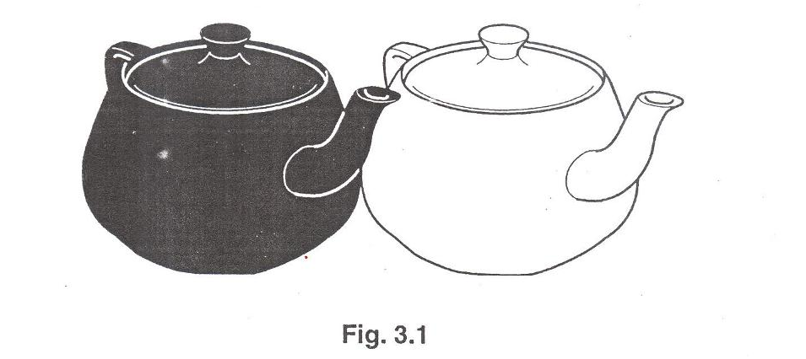
Fig. 7.1
(a) Initially the teapots are in thermal equilibrium with each other.
(i) State what is meant by thermal equilibrium. [1]

(ii) State why the teapots are initially in thermal equilibrium. [1]

(b) Initially, the teapots were filled with the same amount of boiling water.
They are cooling down.

(i) Explain why thermal energy is lost to the air. [1]

(ii) State and explain which teapot will cool down more quickly. [2]

8 During a marathon race, the runner becomes very hot. At the end of the race, evaporation and convection cool the runner.

(a) (i) Explain how evaporation helps the runner to lose energy. Use ideas about molecules in your answer. [2]

(ii) Explain why hot air rises around the runner at the end of the race. [1]

(b) At the end of the race, the runner is given a shiny foil blanket, as shown in Fig. 8.1. Wearing the blanket stops the runner from cooling too quickly.
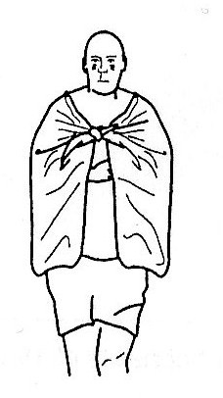
Fig. 8.1

Explain how the shiny foil blanket helps to reduce energy losses. Use ideas about conduction, convection and radiation in your answer. [3]

8 (c) The marathon runner then holds on to a packet of liquid air which contains a mixture of oxygen and nitrogen.

The boiling point of nitrogen is -196 ºC and the boiling point of oxygen is -183 ºC.
The heat transferred from the runner’s palm causes the packet of liquid air to warm up slowly.

Fig. 8.2 shows how the reading of a thermometer in the packet of liquid air, varies with time t.

temperature / °C

-200
-190
-180
t / min

0
2
4
6
Fig. 8.2

(i) Describe the two changes of state that occur and state which period of time did these state changes occur? [2]

(ii) The liquid air contains 20 g of liquid oxygen and 80 g of liquid nitrogen.
The specific heat capacity of liquid oxygen is 1.7 J / (g ºC) and the specific heat capacity of liquid nitrogen is 2.0 J / (g ºC).
Calculate the thermal energy needed to warm the liquid from -205 ºC to -196 ºC.
[2]

9 Every human has a thin layer of air which clings to the skin. This layer is aided by the fine hairs on our body.

(a) State and explain the effect this thin layer of air have on heat loss by the body due to convection currents. [2]

(b) State and explain the behaviour of this fine hair on our skin in warm weather. [2]

10 In a fit and healthy woman, fat layer which is beneath the skin constitutes 25% of the body mass whereas for the corresponding man, the percentage is 18%. State the effect of this layer of fat have on the heat loss by the body and name the method of heat loss. [2]

11 During a brisk walk, Jane who is a 50 kg student uses up 1000 kJ of energy.

(a) Her best friend Ana states that the 1000 kJ of energy has disappeared. State whether she is correct and give a reason. [2]

(b) Name all the body mechanisms which enabled Jane to get rid of the body heat. [3]

12 Explain the following scientifically using concepts in heat:

(a) We shiver in cold weather? [1]

(b) We shiver when we have a fever, even though healthy people in the same room find the temperature comfortable. [1]

(c) We take shelter from rain during winter even when the temperature of the rain and air are at the same temperature. [1]

(d) Very poor people who are forced to sleep outdoors in cold weather use newspaper as f blanket. [1]

(e) Ceiling fan acts to warm up a room during winter when there is a heater on in the room. [1]

(f) Loose-fitting clothes are more comfortable than tight-fitting clothes in a hot climate country like Singapore. [1]

13 For each of the following state whether there has been an increase or unchanged or decrease in the temperature of the object (bold). [7]

 |  | Temperature of bold object
(a) | Jane gets hyperthermia.
(b) | A man rubbing his hands together.
(c) | The air in the steamy bathroom when the exhaust fan is switched on.
(d) | The light of the electric light bulb becomes dimmer.
(e) | You are blowing over your cup of hot chocolate drink.
(f) | A piece of iron which changes its colour from white to red hot.
(g) | A person who dies after an accident.

14 The normal temperature of a healthy person is around 37°C.
Hyporthermia is a condition of dangerous low body core temperature and typically <35°C.
Hyperthermia is a condition of dangerous high body core temperature and typically >41°C.

(a) Complete the following columns two and three. [14]

First aid measures for Janna suffering from hypothermia | Write either C or W  C= Correct step  W = Wrong step | Give reason only when wrong step is used
1. Apply heat to the cold parts.

2. Give alcohol (excluding brandy) to the victim.

3. Rub vigorously the cold parts.

4. Give warm sugary drinks if he victim is conscious
5. Cuddle the victim so that your body temperature provides gentle warmth.
6. Remove the victim from the cold situation
7 Wrap the victim in blankets or a sleeping bag.

First aid measures for Byran suffering from hyperthermia while waiting for medical attention | Write either C or W  C= Correct step  W = Wrong step | Give reason only when wrong step is used
1. Get Byran to drink as much cold water as he can.
2. Let Byran rest in the shade.
3. Put Byran in a bath filled with ice water.
4. Wet Byran’s clothers and let the fan to blow air over him.

(b) State and explain the circumstances likely for hyperthermia to occur. [2]

15 State the most effective method of heat transfer for the following: [3]
(a) from a grilling element to a steak __________________

(b) from one side of a saucepan to the other side, __________________

(c) from the bottom of a pot of boiling vegetables to the top. __________________
14

Solution

1 During a marathon race, the runner becomes very hot. At the end of the race, evaporation and convection cool the runner.

(a) (i) Explain how evaporation helps the runner to lose energy. Use ideas about molecules in your answer. [2]

(ii) Explain why hot air rises around the runner at the end of the race. [1]

(b) At the end of the race, the runner is given a shiny foil blanket, as shown in Fig. 1.1. Wearing the blanket stops the runner from cooling too quickly.
Fig. 1.1

Explain how the shiny foil blanket helps to reduce energy losses. Use ideas about conduction, convection and radiation in your answer. [3]

1 (c) The marathon runner then holds on to a packet of liquid air which contains a mixture of oxygen and nitrogen.
The boiling point of nitrogen is -196 ºC and the boiling point of oxygen is -183 ºC.
The heat transferred from the runner’s palm causes the packet of liquid air to warm up slowly.
Fig. 1.2 shows how the reading of a thermometer in the packet of liquid air, varies with time t.

temperature / °C

-200
-190
-180
t / min

0
2
4
6

(i) Describe the two changes of state that occur and state which period of time did these state changes occur? [2]

(ii) The liquid air contains 20 g of liquid oxygen and 80 g of liquid nitrogen.
The specific heat capacity of liquid oxygen is 1.7 J / (g ºC) and the specific heat capacity of liquid nitrogen is 2.0 J / (g ºC).
Calculate the thermal energy needed to warm the liquid from -205 ºC to -196 ºC.
[2]

2 Every human has a thin layer of air which clings to the skin. This layer is aided by the fine hairs on our body.

(a) State and explain the effect this thin layer of air have on heat loss by the body due to convection currents. [2]

Heat loss by convection is reduced because the trapped air among the fine hairs
cannot move freely.

(b) State and explain the behaviour of this fine hair on our skin in warm weather. [2]

The hair will lie flat on the skin so that there is greater heat loss by convection and
thus the body cools down.

3 In a fit and healthy woman, fat layer which is beneath the skin constitutes 25% of the body mass whereas for the corresponding man, the percentage is 18%. State the effect of this layer of fat have on the heat loss by the body and name the method of heat loss. [2]

Fat is a poor conductor/good insulator of heat due to the presence of water and thus heat
loss by conduction is reduced.

4 During a brisk walk, Jane who is a 50 kg student uses up 1000 kJ of energy.

(a) Her best friend Ana states that the 1000 kJ of energy has disappeared. State whether she is correct and give a reason. [2]

(b) Name all the body mechanisms which enabled Jane to get rid of the body heat. [3]

5 Explain the following:

(a) Why do we shiver in cold weather? [1]

(b) Why do we shiver when we have a fever, even though heathy people in the same room find the temperature comfortable. [1]

(c) Why do we shelter from rain during winter when the temperature of the rain and air are at the same temperature. [1]

6 The normal temperature of a healthy person is around 37°C.
Hyporthermia is a condition of dangerous low body core temperature and typically <35°C.
Hyperthermia is a condition of dangerous high body core temperature and typically >41°C.

(a) Complete the following columns two and three. [10]

First aid measures for Janna suffering from hypothermia | Choose either C or W  C= Correct step  W = Wrong step | Give reason only when wrong step is used
1. Apply heat to the cold parts.
2.Give alcohol to the victim.
3. Rub vigorously the cold parts.
4. Give warm sugary drinks if he victim is conscious
5. Cuddle the victim so that your body temperature provides gentle warmth.
6. Remove the victim from the cold situation
7 Wrap the victim in blankets or a sleeping bag.

(b) State and explain the circumstances likely for hyperthermia to occur. [2]

