Assignment 9
KT Theory of Matter

Name: __________________ ( ) Class: ____ Date: _______ Mark: _____/22

1 Which graph shows the relationship between the pressure and volume of a fixed mass of gas at constant temperature? ( )
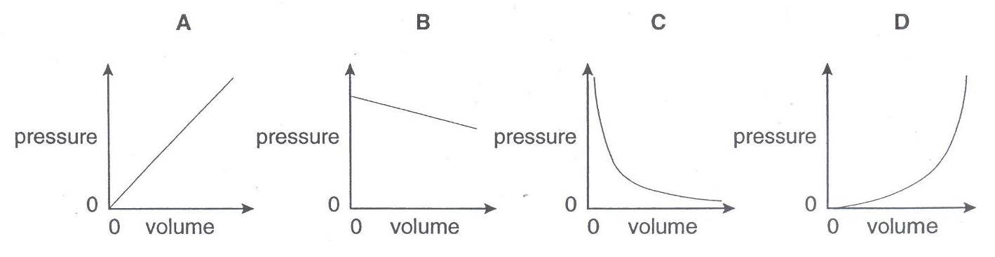
2 Assuming the temperature remains constant, which combination correctly describes the volume and the shape of a gas or liquid? ( )
 | gas or liquid | volume | shape
A | gas | fixed | not fixed
B | gas | not fixed | not fixed
C | liquid | fixed | fixed
D | liquid | not fixed | fixed

3 Smoke particles in a transparent box are observed using a microscope. A small point of light is seen to move around as shown.
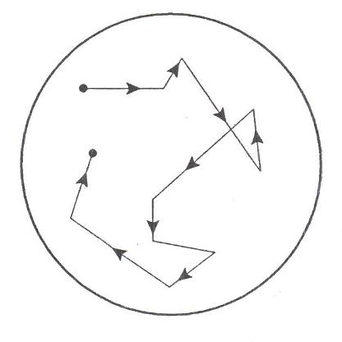
What does this experiment demonstrate about air molecules? ( )
A They are in continuous random motion.
B They can be seen through a microscope.
C They move more quickly when they are heated.
D They move because of collisions with smoke particles.

4 Some oxygen gas is in a sealed container that has a constant volume.
What will happen to the oxygen molecules when the gas is heated? ( )

A They will expand.
B They will move more quickly.
C They will move further apart.
D They will become more dense.
5 The diagram shows an experiment to look at the behaviour of smoke particles in air.
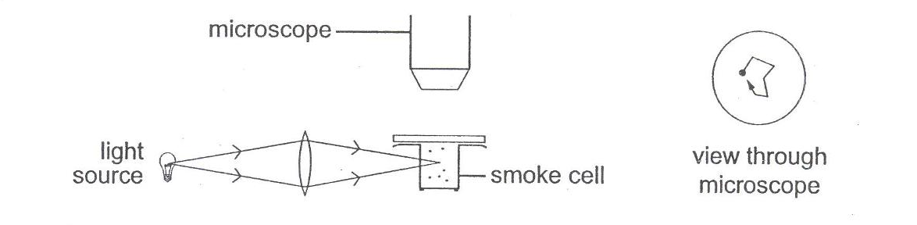
Why is each smoke particle seen to move about at random? ( )
A Air molecules collide with smoke particles.
B Convection currents cause the air to move.
C Draughts cause the smoke particles to move.
D Smoke particles gain kinetic energy from the light.

6 Gas inside a cylinder is heated slowly to a higher temperature. The pressure inside the cylinder remains constant as the piston moves outwards.
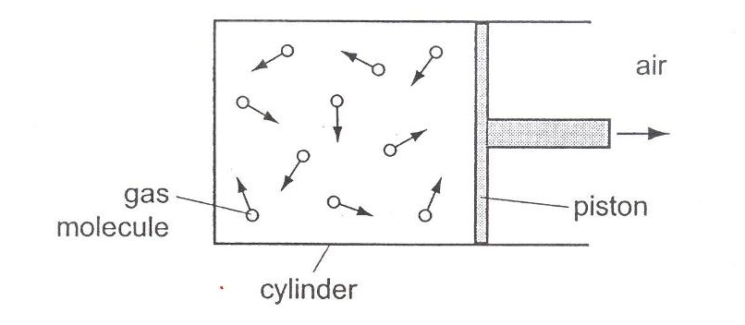
How do the speed of the gas molecules and their rate of collision with the piston compare with their initial values at the lower temperature? ( )
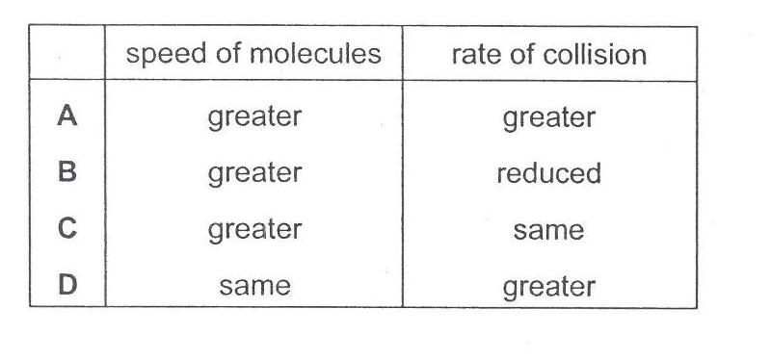
7 A thin-walled plastic bottle is sealed and contains dry air at atmospheric pressure.
(a) Explain how the molecules of air inside the bottle exert a pressure on the walls.
............................................................................................................................................
............................................................................................................................................
............................................................................................................................................
...................................................................................................................................... [2]
(b) lce is placed inside the bottle, and the bottle is then sealed again. The temperature of the air inside the bottle falls and the bottle becomes partially crushed. Explain, in terms of the molecules of air inside and outside the bottle, why this happens.
............................................................................................................................................
............................................................................................................................................
............................................................................................................................................
............................................................................................................................................
...................................................................................................................................... [4]
.............................................................................................................................................
......................................................................................................................................... [1]

8 (a) Brownian motion provides evidence that the molecules in a gas are moving.
(i) Draw a labelled diagram of an experiment that demonstrates Brownian motion. [2]

(ii) Describe what is seen and explain how this shows that molecules are moving. [3]

9 Fig. 9.1 shows air in a cylinder at room temperature. The piston is free to move.

0
10
20
30
air at room temperature
cm³

Fig. 4.1

When the cylinder is placed in a very cold freezer, the piston moves inwards.
Fig. 4.2 shows the position of he piston after it has stopped moving.

0
10
20
30
Fig. 4.2
cm³
cold air

At room temperature, the density of the air in the cylinder is 0.0012 g/cm³.

(a) Determine the density of the cold air. [2]

(b) The pressure of the air in the cylinder in Fig. 4.1 is the same as the pressure of he air in the cylinder in Fig. 4.2.

Explain how the molecules in the cylinder

(i) create a pressure, [1]

(ii) create the same pressure in Fig. 4.1 and Fig. 4.2. [2]

(c) Explain what causes the piston to move inwards as the cylinder is cooled. [1]

