9. Transfer of Thermal Energy

• Conduction
• Convection
• Radiation

(a) Show understanding that thermal energy is transferred from a region of higher temperature to a region of lower temperature
(b) Describe, in molecular terms, how energy transfer occurs in solids
(c) Describe, in terms of density changes, convection in fluids
(d) Explain that energy transfer of a body by radiation does not require a material medium and the rate of energy transfer is affected by:
(i) colour and texture of the surface
(ii) surface temperature
(iii) surface area
(e) Apply the concept of thermal energy transfer to everyday applications

Notes
1 What is heat transfer?
It refers to the n___ transfer of heat e________ from h____ regions to c______. This law is also known as Zeroth Law of thermodynamics. There are _______ methods of heat transfer.

2 What is conduction?
It is the transfer of th________ energy through a m_________ without any mov_____ of the medium.

Conduction occurs as a consequence of excess energy of v___________ being passed along from atom to a____ in all so_______.
In all m_______, excess k_______ energy given to f_____ electrons near the source of heat is being carried by these electrons as they dif_________ towards col______ regions. This energy is converted back to vi_____________ energy when electrons col_____ with atoms. This mechanism is known as free electron diffusion. Conduction in liquids and gases is not efficient because the particles are spaced f_________ apart than those in solids. Also there is lesser co__________ between the particles present resulting in slower transfer of k______ energy.

3 What is convection?
It is the transfer of thermal energy by means of c___________ currents in a f______ (liquid or gas), due to a difference in d________. Convection current do not occurs in s______.

4 What is radiation?
It is the transfer of energy in the form of electromagnetic waves such as in________ radiation
without requiring a m_______.

5 The factors affecting the rate of emission and absorption of infrared radiation are

1. Co______ and tex_______ of the surface
2. Surface tem_______
3. Surface ar_______.
Applications of Thermal Energy Transfer.

Good conductors of heat are used in cooking utensils, soldering iron rods and heat exchange.

Kettles, saucepans and boilers are usually made of al_________ or sta_______st_____ where thermal energy is transferred quickly through the metal.

Poor conductors of heat (in__________) are used to pr_______ thermal energy being transferred quickly. Insulators can prevent inj_____ and damage in the application of h_________ of uten____ and appliances and in table mats. Another function of insulator is the ability to reduce heat loss ____. Examples would include clothing for _________ weather, d______ glazed windows and saw d____ used to cover ice blocks and polys______ foam in the walls of refrigerator

Common applications of convections
Electric kettles, Household hot water systems and Air Conditioners

Common application of radiation
Green Houses, Vacuum Flask

Classwork
1 Explain why the tip of the soldering iron rod is made of copper instead of steel.

____________________________________________________________________________

2 A heat pipe is a device that transmits thermal energy along its length. It can transmit energy thousands of times faster than a solid copper rod. Fig. 9.1 shows a heat pipe attached to black metal fins. The ﬁns absorb energy from the Sun. The sealed pipe transmits this energy along its length into a tank of
cold water
. 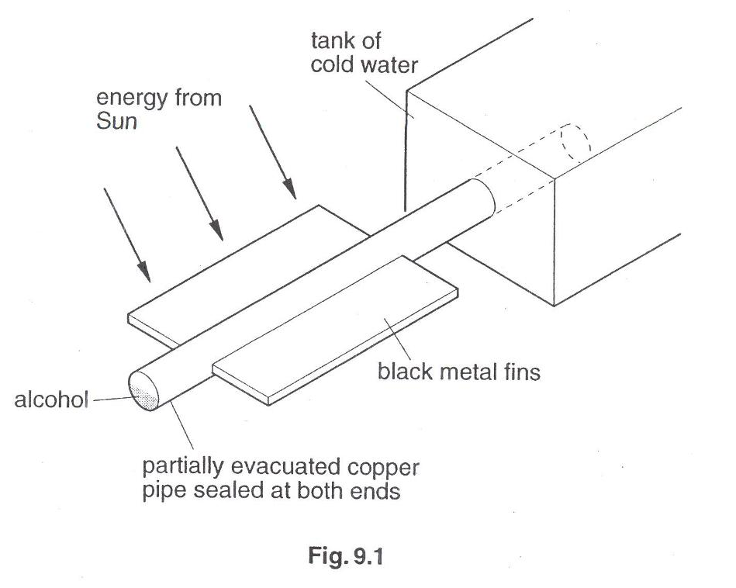
Fig. 2.1
Thermal energy from the fins is conducted through the walls of the copper pipe and causes the alcohol to boil. The boiling creates a higher pressure. At the end of the copper pipe in contact with cold water, the alcohol condenses and creates a lower pressure. The liquid alcohol runs along the pipe to be boiled again. There is little change in the temperature of the alcohol.

(a) Describe how molecules in the copper conduct energy to the alcohol. [1]

(b) Explain how boiling and condensation within the heat pipe cause the transfer of energy.

(b) Explain why the heat pipe is able to transfer energy at a fast rate. [1]
_______________________________________________________________________

10. Thermal Properties of Matter

• Internal energy
• Melting, boiling and evaporation

(a) Describe a rise in temperature of a body in terms of an increase in its internal energy (random thermal energy)
(b) Describe melting/solidification and boiling/condensation as processes of energy transfer
without a change in temperature (c) explain the difference between boiling and evaporation

7 Fig. 7.1 shows the cooling system of a car radiator where water is used as the coolant.

outflow pipe
fan draws air through radiator
cap
thermostat
pump
water jacket
radiator
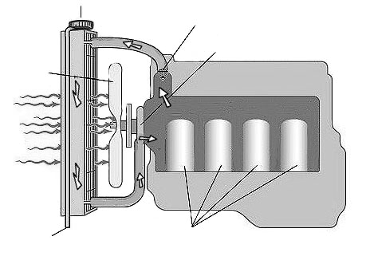

airflow

engine

Fig. 7.1

The engine is surrounded by a water jacket. When the water in the jacket is heated, it flows upwards into the radiator where it is cooled by the flowing air. The cooled water flows down and returns back to the jacket through a water pump.

(a) Describe how the rotating fan draws air through the radiator. [2]

(b) Explain why the radiator is made from aluminium and is painted black. [2]

3 | The figure illustrates the structure of a solar heating system.  hot water tank  solar radiation  absorption panel containing water pipes  glass cover  expanded polystyrene
 | (a) | By what process does the hot water rise up the water pipes? Explain why this process occurs.
 | (b) | Explain why the system is more effective when  (i) the surface of the absorption panel is blackened,  (ii) expanded polystyrene is used as the backing board.

