Assignment
Latent Heat and Specific Heat Capacity

Name: __________________ ( ) Class: 3/____ Date: _______ Mark: _____/36
1 In an experiment to determine the specific heat capacity of a liquid, a 0.12 kW immersion heater is used to heat the liquid. During the heating, the liquid was constantly stirred. The graph below shows how the temperature of the liquid changes with time.
temperature / °C
time / s
0
50
100
200
250
300
30
40
50
60
70

B
C

A

150

(a) From the graph calculate a value for the heat capacity of the liquid. [2]

(b) Explain why the value you have calculated is bigger than the actual value. [1]

(c) Explain why the liquid is constantly stirred during the experiment. [1]

(d) What happens to the liquid along BC of the graph? [1]

- Explain, in molecular terms, what has happened to the heat supplied by the heater along BC. [2]

(f) Calculate a value of the specific latent heat of vaporisation of the liquid if 10 g of the liquid evaporates during the time B to C. [2]

2 A student carried out an experiment to find the specific latent heat of fusion of ice by the method of mixtures. He placed 0.02 kg of ice at 0°C into a plastic cup (of negligible heat capacity and with good insulation) containing 0.05 kg of water at 20°C.

(a) Calculate the heat energy lost by water if the final temperature of the mixture is 0°C. (Specific heat capacity of water = 4,200 J kg⁻¹K⁻¹) [2]

(b) Calculate the heat energy required if all the ice has melted. (Specific latent heat of fusion of ice = 336,000 J kg⁻¹) [2]

(c) Hence by considering the answers of (a) and (b), find the final temperature of the mixture. [1]

(d) The student found that he could not obtain an experimental value for the specific latent heat of fusion of ice from this experiment. Why? [1]

3 A student performs two experiments to determine the melting points of two substances M and N each of mass 0.10 kg. They are heated in identical test tubes from solid to liquid state and then allowed to cool at the same time. The temperature of M and N are recorded at one-minute intervals.

Time in min | 1 | 2 | 3 | 4 | 5 | 6 | 7 | 8 | 9 | 10 | 11
Temperature of M in °C | 72 | 64 | 56 | 50 | 50 | 50 | 50 | 50 | 49 | 45 | 41
Temperature of M in °C | 65 | 50 | 35 | 35 | 35 | 32 | 29 | 26 | 26 | 26 | 26

(a) Plot a cooling curve (temperature against time) for substances M and N on the same graph. [4]

(b) From the graph, find the [5]

(i) temperature of the liquids when the experiment started, _____________
(ii) melting points of M and N, and _______________________
(iii) the room temperature at which the experiments were carried out. Explain how you deduced your answer.

(c) Which liquid, M or N has a lower specific heat capacity? Explain your answer. [2]

(d) Calculate the heat released by N during the entire cooling process [4]
[ the specific heat capacity of liquid N = 2100 J/(kg K)
the specific latent heat of fusion of liquid N = 160,000 J/kg and
the specific heat capacity of solid N = 3200 J/(kg K)]

4 The diagram below shows one way to measure the specific latent heat of vaporization of steam in the laboratory. A mains immersion heater that is connected to a kilowatt-hour (kWh) meter is used to boil off water at 100°C from a container. By recording the amount of energy supplied and the mass of water boiled off, the specific latent heat of vaporization of steam can be found.
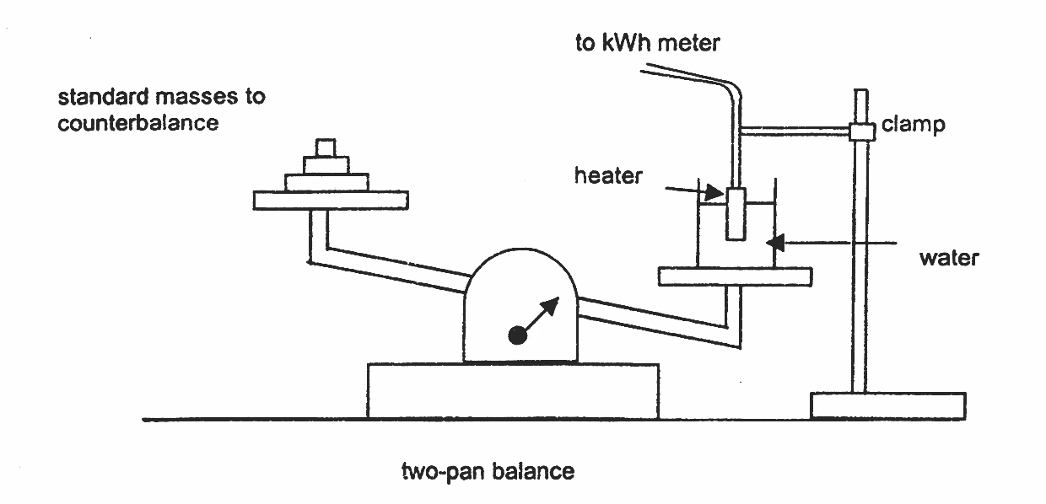
(a) The two-pan balanced is usually set to become horizontal in the first place. However, this cannot be achieved normally by adding standard masses (e.g. 1 gram) to the left pan of the balance. Explain why is this so and suggest one way to make the pan balance. [3]

(b) When the two-pan balance is in equilibrium and the water is boiling, a 200 g mass is then added to the right pan to tilt the two-pan balance. The initial kilowatt-hour meter reads 10.0 kWh then. After boiling for a while, the two-pan balance is in equilibrium again and the meter now reads 10.2 kWh. [5]

(i) What is the weight of water that has boiled off?

(ii) Calculate the specific latent heat of vaporization of steam if 37.5% of electrical energy is lost to the surrounding.

(c) In another experiment, the student now pushes a larger portion of the heater into water. Describe and explain the effect this has on the value in (b) (ii). [2]

(d) A student suggested that there is heat lost by convection at the surface and the accuracy should improve with the use of a cover. Do you agree and why? [2]

