Name: __________________ ( ) Class: _______ Date: _________

Worksheet 10.1
Heat Transfer

- Explain why solids have fixed shapes but liquids take the shape of their containers. In your answer you should include how the motion and separation of the molecules differs between the 2 states

___________________________________________________________

___________________________________________________________

___________________________________________________________

___________________________________________________________

- The figure below shows three different cans A, B and C. Each can is filled with hot water at a temperature of 80°C.

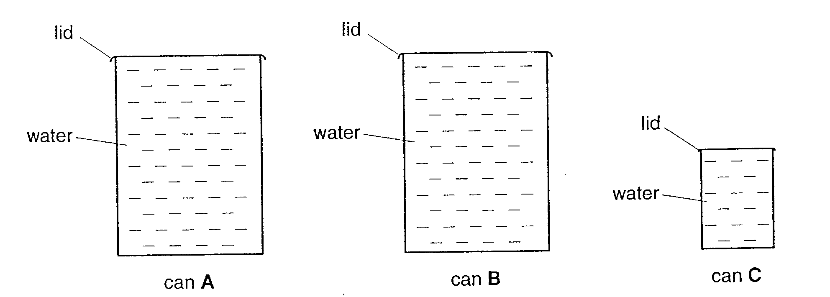
Cans A and B are the same size; can C is smaller.
Can A has a shiny silver surface.
Can B has a different surface to can A.
Can C has a similar surface to can B.

- Can B radiates heat at a higher rate than can A. Suggest two reasons why this may be so.

________________________________________________________

________________________________________________________

________________________________________________________

- State whether can C radiates heat at a higher or lower rate than can B. Explain your answer.

________________________________________________________

  - The diagram below shows how an Alaskan meringue is made. Ice cream insulated with sponge cake is baked in an oven.

Ice cream
Sponge cake mix
Wire rack

Heating elements

    - Describe how heat travels from the heating element to the plate of meringue.

………………………………………………………………………………………………
………………………………………………………………………………………………

    - Explain why the ice cream does not melt although it is baked in an oven.
………………………………………………………………………………………………
………………………………………………………………………………………………

3. Fig. 3.1 shows two cooking pans with different inner and outer surfaces.

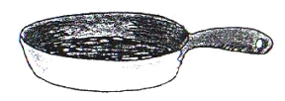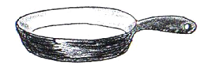

Pan A: outer surface shiny and Pan B: outer surface black and
inner surface black inner surface shiny

Fig. 3.1

You want the cooking pan to have the following two features:
- absorb thermal energy from the flame as quickly as possible,
- have an inner surface that remains as hot as possible during cooking.

Which pan would you buy? Give your reasons.

……………………………………………………………………………………………………………………
……………………………………………………………………………………………………………………
……………………………………………………………………………………………………………………

--- END ---

