Name: __________________ ( ) Class: _______ Date: _________

Worksheet 11.1
Changes of State

- The graph below shows the temperature of a certain liquid as it is being heated by a bunsen burner.

  - What is the boiling point of the liquid and how long did it take to boil? [2]

Boiling point =

Time taken to boil =

  - To make the liquid heat up faster, a student decided to change the container of the liquid. Suggest what colour and material should be used for the container. Justify your solution with a reason. [4]
Colour:

Material:

  - Explain why the temperature remains constant during boiling. [2]

2 a) Describe two differences between the arrangement and movement of molecules
of ice and water.[2]

………………………………………………………………………………………………
………………………………………………………………………………………………
………………………………………………………………………………………………
………………………………………………………………………………………………

- The diagram below shows the temperature of water as it is heated over some time.
Time/min
temp/°
5
3
4
100

Describe the molecular behaviour of water molecules from 3min to 5min. [2]

………………………………………………………………………………………………
……………………………………………………………………………………………………………………………………………………………………………………

3 Give 2 differences and 2 similarities between boiling and evaporation.

4 Explain why John feels cooler after perspiring.

5 In an experiment to determine the boiling point of a liquid, a 0.12 kW immersion heater is used to heat the liquid. During the heating, the liquid was constantly stirred. The graph below shows how the temperature of the liquid changes with time for part of the heating process.

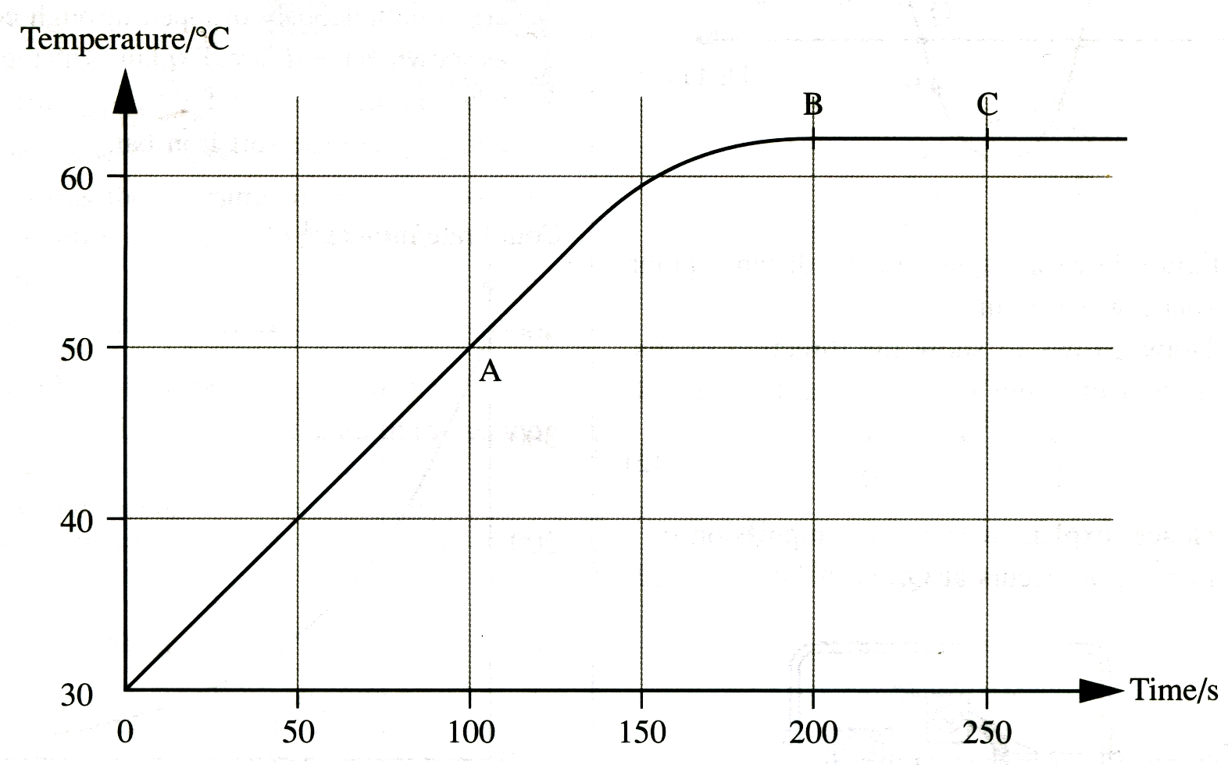

a) Explain why the liquid is constantly stirred during the experiment.

________________________________________________________________

b) i) What happens to the liquid along BC of the graph?

________________________________________________________________

ii) Explain, in molecular terms, what has happened to the heat supplied by the heater along BC.

________________________________________________________________

________________________________________________________________

--- END ---

