Name: _______________________________ ( ) Class: ______________ Date: __________

Refraction and Total Internal Reflection
Student’s Handout
Topic: Waves |  | Estimated Duration: 1 hour

- Aim
In this activity, you will explore the concepts of refraction and total internal reflection using ICT tools.
Refraction
Question for recap:
- How is the angle of incidence related to the angle of refraction? (You can answer using a statement
or formula.)
_____________________________________________________________________________________
Instructions (Figure 1):
- Go to the URL: http://phet.colorado.edu/en/simulation/bending-light and click on “Run Now!”
- Click on the “Intro” tab on the top left corner of the simulation.
- Select the material Air and Mystery A as shown below.
- Drag the protractor to align 0° with the normal.
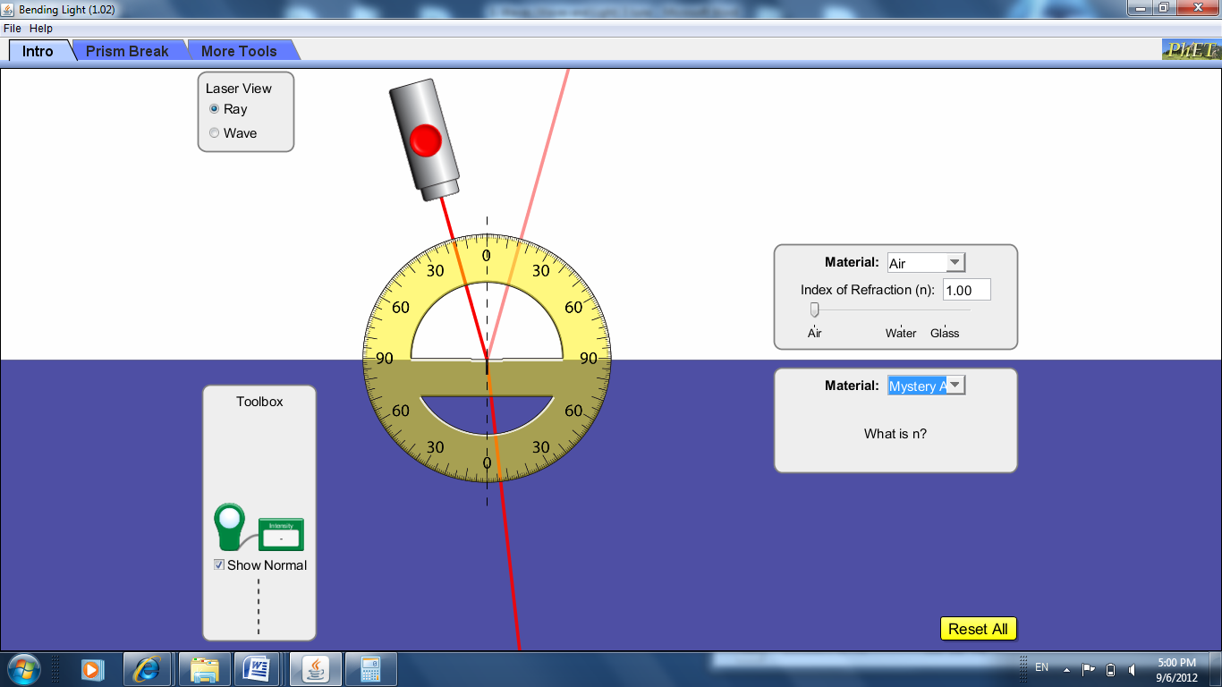Figure 1

Observations:
- Record the angle of incidence, i, and the angle of refraction, r, in the table below. Complete the calculations for sin i, sin r and n.

i | r | sin i | sin r | n = sin i / sin r

Questions:
- What is the refractive index, n, of the material Mystery A?
_______________________________________________________________________
- a. Plot a graph of sin i against sin r (on the following page) and calculate the gradient of the graph
using the space below.

- What did you observe about the answers to question 3 and 4a above?
_____________________________________________________________________
_____________________________________________________________________
- Why do we need to plot graphs to calculate the refractive index n?
_____________________________________________________________________
_____________________________________________________________________
_____________________________________________________________________
_____________________________________________________________________

Total Internal Reflection
Instructions (Figure 2):
For total internal reflection to take place, the light ray has to travel from a denser to a less dense medium. Hence, change the material to glass for the medium that the light source is in (top half), and air for the medium that the light is travelling into (bottom half).

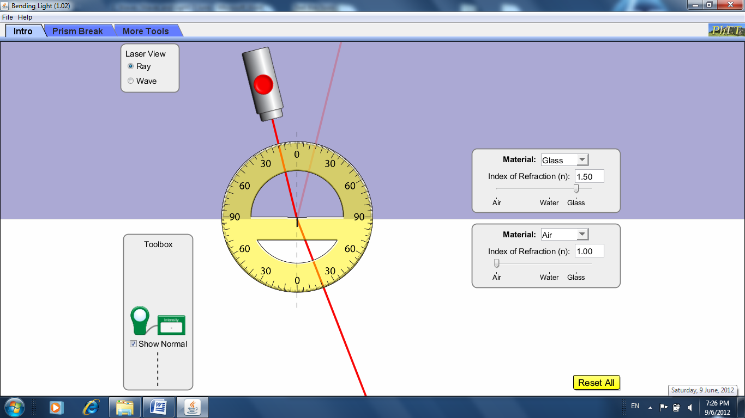
Figure 2
Reflected ray
Refracted ray

Observations:
    - Increase the angle of incidence until the refracted ray “disappears” (Figure 3). The refracted ray “disappears” because the ray is totally and internally reflected. This phenomenon is known as total internal reflection.
    - When the angle of incidence, i, is equal to the critical angle, the refracted ray passes exactly along the boundary of the two media. When i exceeds the critical angle, total internal reflection occurs.

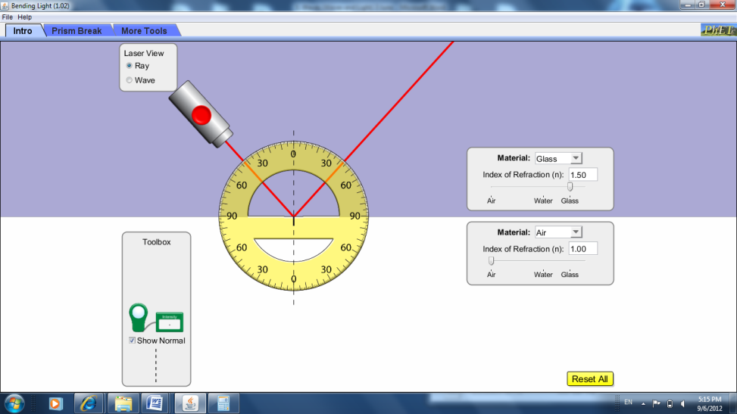
Figure 3
Total internal reflection

Questions:

- For the glass medium above, record the angle just before the refracted ray “disappears”, or the critical angle.
Critical angle of glass: ________
- Repeat the above step to find the critical angles of the other media:
- Critical angle of water : _________
- Critical angle of Mystery A : _________
- Critical angle of Mystery B : _________

- Do all media have the same critical angle?
_______________________________________________________________________

_______________________________________________________________________
_______________________________________________________________________

- Will the same phenomenon occur if light is travelling from a less dense medium into the denser medium? Explain your answer.

_______________________________________________________________________

_______________________________________________________________________

_______________________________________________________________________
Refraction and Total Internal Reflection
Teacher’s notes
Stream: Express /  Normal (Academic) |  | Topic: Waves |  | Estimated Duration:  2 activities of 1 hour each

- Description of activity
There are two lessons in this package. In Lesson 1, students make observations of demonstrations and perform experiments to appreciate the phenomena of refraction and total internal reflection. In Lesson 2, students make use of the PHET Bending Light applet to deepen their understanding of the concepts of refraction and total internal reflection.

- Key Focussing Question
What is the relationship between the angle of incidence and angle of refraction of a ray of light that bends as it moves from one transparent medium into another?
- Aim
Lesson 1
Students will observe and appreciate the phenomena of refraction and total internal reflection.
Lesson 2
ICT is used to further deepen students’ understanding of the concepts of refraction and total internal reflection.

- Objectives
- Related Syllabus Learning Outcome
This lesson exemplar addresses the following learning outcomes:
- Recall and apply the relationship sin i / sin r = constant to new situations or to solve related problems
- Explain the terms critical angle and total internal reflection
- Skills and Processes
Students are required to manipulate apparatus, equipment and various ICT simulations. They also have to be able to make observations of the demonstrations, experiments and simulations, as well as to infer and communicate conclusions about their observations.
- 21CC
CIT – Sound Reasoning, ICS – Management of Information:
Students have to be able to use experimental data to draw implications and conclude
about Snell’s Law. From this, students make use of ICT tools to develop further
understanding about the concepts of refraction and total internal reflection.

- Prior knowledge
Students have learnt to:
  - recall and use the terms for reflection, including normal, angle of incidence and angle of reflection,
  - state that, for reflection, the angle of incidence is equal to the angle of reflection and use this principle in constructions, measurements and calculations, and
  - recall and use the terms for refraction, including normal, angle of incidence and angle of refraction
In lower secondary, under the theme “Models”, students have learnt that models are simplified representations of phenomena constructed to explain the phenomena, and used to make predictions.

- Materials
Lesson 1

Lesson Introduction

- Stirrers, containers and other objects made of pyrex glass
- Oil (Baby oil is recommended as it is colourless)

Lesson Development
- Relationship sin i / sin r = constant
Alternative 1
Use equipment as seen in the video under Alternative 2 below:
- Protractor template
- Semi-circular glass prism
- Ray box
Alternative 2
Video to demonstrate refraction, angle of incidence and angle of refraction:
Go to https://sites.google.com/site/quantumboffin/
→ under “Physics Videos” select “Snell’s Law”.
- Critical angle and Total Internal Reflection
- Fish tank or transparent bottle and green laser:
There are many video demonstrations on the internet of total internal reflection that can be easily repeated in the classroom. The titles and description of two such YouTube videos are:
  - Laser Viewing Tank
A fish tank, a green laser and some scattering agent produce a demonstration tool that allows students to see and control light beams
  - Toys from Trash → Total Internal Reflection
A transparent bottle of water, some Dettol, and a green laser are used to produce an effective tool for demonstrating total internal reflection

Lesson 2

Further visualization exercise and practice using PHET Bending Light applet
- Student’s handout (Refraction and Total Internal Reflection Worksheet)
- Computer laboratory or portable laptops
- PHET Bending Light applet:
Go to http://phet.colorado.edu/en/simulation/bending-light
(Note: Teachers can choose to download and save this applet on every computer/ laptop before the lesson)
- Suggested lesson guide
Lesson One
Assessment indicators | Lesson Activity | Pedagogical Considerations
Evidence of learning is shown when students are able to…. | Lesson Introduction ..  Demonstration using containers and stirrers made of pyrex glass and oil – Watch pyrex glass objects disappear when immersed in oil placed in pyrex glass containers. Teachers can make the demonstration more interesting by immersing an opaque object next to the pyrex one for comparison. Another variation is to half-fill the container with water followed by oil so that the pyrex object will disappear partially when immersed. | Trigger activity to stir curiosity and stimulate questions about the observed phenomena.
articulate that the ratio sin i/sin r is a constant for the different sets of angle of incidence i and angle of refraction r.  Evidence of learning is shown when students are able to….  articulate that the ratio sin i /sin r is known as the refractive index for light travelling from vacuum to an optical medium.  define critical angle and total internal reflection. | . Lesson Development ..  - Relationship sin i / sin r = constant  Alternative 1  If the apparatus as shown on the video is available, especially the semi-spherical glass block, the teacher can choose to have students perform the activity. The template as shown on the video should be prepared and printed for all students.  (Video: https://sites.google.com/site/quantumboffin/ → select “Snell’s Law” under Physics Videos)  - Students calculate and record the values of sin i /sin r for the different sets of i and r.  - Observation: The ratio sin i/sin r is approximately the same for all the sets  of values of i and r.  - Conclusion: This ratio is a constant for two given transparent media. This is  known as Snell’s Law.  Alternative 2  Show the “Snell’s Law” video from Quantum Boffin to allow students to observe refraction. Direct students’ attention to the fact that the angle of incidence, i, has a different value from the angle of refraction, r.  (Video: https://sites.google.com/site/quantumboffin/ → select “Snell’s Law” under Physics video)  - Further discussion to introduce the refractive index n  From the above activity (Alternative 1), students have seen for themselves that the ratio sin i /sin r is a constant for different sets of i and r. Teacher leads the discussion further to explain that for light travelling from vacuum to an optical medium, this constant is then known as the refractive index n.  - Critical angle and Total Internal Reflection  - The suggested videos or actual demonstrations from the videos can be used to show that:  - as the angle of incidence increases, it will reach a particular angle where the refracted ray passes exactly along the boundary of the two media. This particular angle of incidence is known as the critical angle.  - when the angle of incidence exceeds the critical angle, the ray reflects internally and this phenomenon is known as total internal reflection.  (Refer to Materials list for videos: Laser Tank OR Toys from Trash) | Preparing templates with protractor markings (as shown on the video) allows students to concentrate on observing the phenomenon of refraction.  21CC:  Students observed that the ratio sin i/sin r yields the same value for different sets of i and r, and they should be able to reason and conclude from the data that for the two given transparent media, the ratio is a constant, satisfying Snell’s Law.  This is a logical development of concepts where Snell’s Law is developed first before introducing the refractive index.  This is a simple and yet effective demonstration of total internal reflection to make the phenomenon real for students.
Lesson conclusion ..
- For any 2 given transparent media, the ratio of sin i to sin r is always a constant. This is known as Snell’s Law.
- For light travelling from vacuum to an optical medium, this constant is a characteristic of the medium known as its refractive index.
- Definitions of critical angle and total internal reflection.
Lesson Two
Assessment indicators | Lesson Activity | Pedagogical Considerations
Evidence of learning is shown when students are able to…. | Lesson Introduction ..  Recap of concepts learnt from previous lesson:  - For any two transparent media, the ratio of sin i to sin r is always a constant. This is known as Snell’s Law.  - For light travelling from a vacuum into a given transparent medium, this constant is a characteristic of the medium known as its refractive index.  - Definitions of critical angle and total internal reflection.  Objective of the day’s lesson:  Further exploration of the phenomena of refraction and total internal reflection through ICT tools.
apply the formula to calculate the refractive index, n.  Evidence of learning is shown when students are able to….  - obtain the refractive index, n, from gradient calculation.  - state the two conditions for total internal reflection to take place. | Lesson Development .  Activity on Refraction:  - Distribute the student’s handout (Light – Refraction and Total Internal Reflection)  - Students are to follow the instructions on the worksheet to access the PHET Bending Light applet (http://phet.colorado.edu/en/simulation/bending-light).  - Teacher is to emphasize the following before students begin:  - Although vacuum is not available as a material selection, air can be selected as the next best medium to replace vacuum for calculating the refractive index.  - The refractive index n is a ratio that is a unique characteristic of the glass block.  - Students are to commence work on the applet. They make use of the applet to  record i, r, and calculate values of sin i, sin r and n.  - Students plot a graph of sin i against sin r and answer further questions to:  - conclude that the gradient of the graph yields the refractive index.  - understand the difference between calculation of refractive index from point data of sin i and sin r versus that derived from a graph of sin i against sin r.  Activity on Total Internal Reflection (TIR):  From the worksheet, the following conclusions can be derived:  - TIR occurs when the ray is not able to leave the glass anymore and is totally and internally reflected.  - For TIR to take place, the light ray has to travel from a denser to a less dense medium.  - When the angle of incidence is equal to the critical angle, the refracted ray passes exactly along the boundary of the two media and when it exceeds the critical angle, total internal reflection occurs.  - Critical angle is a property unique to different transparent media. | This applet is a convenient tool for students to further explore refraction and total internal reflection.  These questions allow students to practise the calculation of refractive index from application of the formula on the point data as well as the graphical method; and also to note the difference between the two methods.  This applet allows students to observe refraction and total internal reflection as they manipulate the incident ray through a range of angles of incidence.
Lesson conclusion ..
- Calculation of refractive index from graph of sin i against sin r.
- Conditions for total internal reflection to take place.

- Additional notes for teacher
Some common misconceptions on Waves
Students have difficulty understanding that waves transfer energy from a disturbance to other places without the transfer of matter. Students often think that:
- Waves transport matter.
- There must be a medium for a wave to travel through.
- Waves do not have energy.
- All waves travel the same way.
Refer to Handbook for Teaching Secondary Physics (Chapter 9) for more on the teaching of Waves.
- Suggested answers to activity
Refraction
1. The ratio of sine i to sine r is a constant.
4b. The answers to 3 and 4a are close estimates of each other.
4c. The gradient is calculated from the best fit line through all plotted points. Hence, the error
would have been minimized.
Total Internal Reflection
- Approximately 41°
- Critical angle of water: Approximately 48°
Critical angle of Mystery A: Approximately 25°
Critical angle of Mystery B: Approximately 45°
- No. The materials above have different critical angles.
- No. The two conditions for total internal reflection to take place are (1) the light ray has to travel from a denser to a less dense medium and (2) the angle of incidence has to exceed the critical angle.
- References
- Snell’s Law video from Quantum Boffin homepage
- Bending Light java applet from PhET Interactive Simulations, University of Colorado
- Ministry of Education and Academy of Singapore Teachers. (2011). The Handbook for Teaching Secondary Physics. Singapore: Ministry of Education.
- Acknowledgement
- Snell’s Law video from Quantum Boffin homepage
https://sites.google.com/site/quantumboffin/
- The Bending Light java applet is taken from:
PhET Interactive Simulations
University of Colorado
http://phet.colorado.net
- This lesson was developed with feedback from Mr Chan Yook Mun [ST/Nan Chiau High School, Physics Subject Chapter (AST) Zonal Representative (North)]

