Aim: Investigate the light emitted from the sun
Apparatus: Computer Lab with the following software programmes and pictures
Tool: Download at http://www.cabrillo.edu/~dbrown/tracker/
Other Software: Update to lates Java
Pictures: “solar spectrum.png”, “H.jpg”, “He.png”, “Na.png”
Contact: Lee Tat Leong (lee_tat_leong@moe.edu.sg)

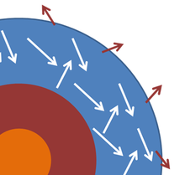
Background:
A star often is modeled as a blackbody, and electromagnetic radiations emitted from these bodies are known as blackbody radiation. The figure shows a highly schematic cross-section to illustrate the idea. The photosphere of the star where the emitted light is generated is idealized as a layer within which the photons of light interact with the material in the photosphere.

The sun generates its energy primarily through nuclear fusion of hydrogen (isotopes) to helium.
For details, refer to the lecture on Nuclear Physics.

Activity 1 The solar emission spectrum
- Launch Tracker software.
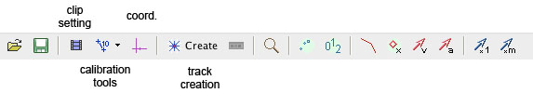
Fig. 1: Tracker’s analysis tools
- Click (or File|Open menu item) and select the picture “solar spectrum.png”.
- To calibrate the points on the picture, click the calibration tool and select Calibration Points.
- Change the axes to “X only”.
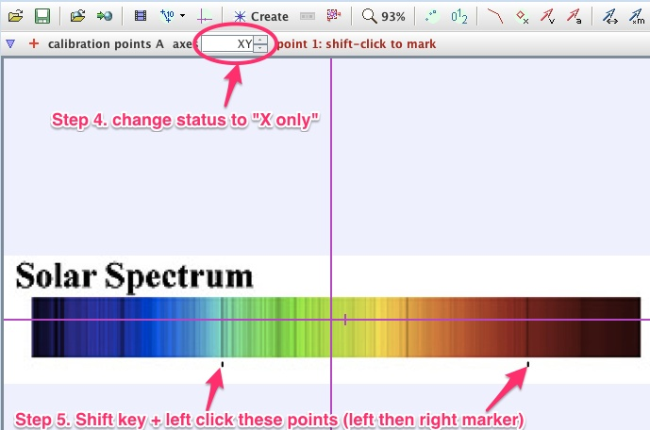
Fig. 2: calibrating the picture

- Hold the shift key & left click on the two black markers (left and right) below the spectrum (these are the reference wavelengths). Enter 486 nm and 656 nm for point 1 and for point 2 respectively.
Fig. 3: Setting the reference wavelength
- Click Create and choose Line Profile.
  - By holding down the shift key, left click & drag with the mouse across the spectrum (start from within the spectrum from the left to the right) to create a line profile.
  - Change the spread to about 5 to take an average reading of the intensity of the spectrum.
  - The plot on the right hand side shows the brightness/intensity (luma) against the wavelenght in nanometres.

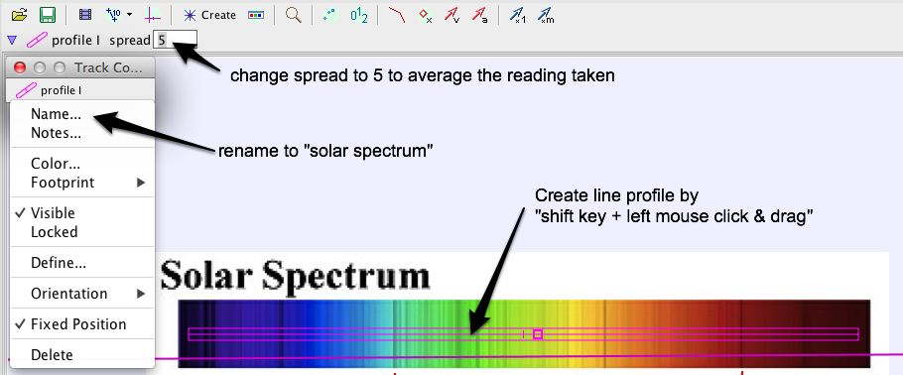
Fig. 4: Creating a line profile

- Right-click on the plot and choose analyse… in the popup menu.
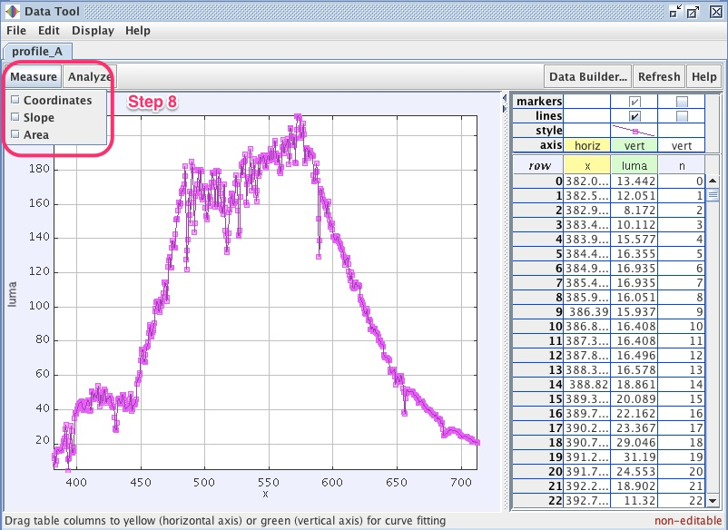
Fig. 5: Data analysis window
- Select Measure and then Coordinates checkbox. Move the crosshair within the graph area to read the wavelength (x-axis) and the corresponding intensity (y-axis).

Record the wavelengths of the spectrum where intensity dips by a large amount
λ₁ / nm | λ₂ / nm | λ₃ / nm | λ₄ / nm | λ₅ / nm | λ₆ / nm | λ₇ / nm | λ₈ / nm
Explain why such dips occur.

………………………………………………………………………………………………………

………………………………………………………………………………………………………

………………………………………………………………………………………………………
Activity 2 Exploring the formation of the absorption lines in the solar spectrum
Without closing the tracker software programme, analyse the emission spectrum of Sodium, Helium and Hydrogen (“Na.png”, “He.png” and “H.jpg”) following activity 1’s step 2 to 8.

2.1 Sodium (Na.png)
Record the wavelength spike where the intensity is the highest.
λ_{Na,1} / nm

Explain the origin of these spikes in the spectrum.

……………………………………………………………………………………………………………………

……………………………………………………………………………………………………………………

……………………………………………………………………………………………………………………

2.2 Helium (He.png)
- For step 5, hold the shift key & left click on the white markers (left and right) below the spectrum (these are the reference wavelengths). Enter 486 nm and 656 nm for point 1 and for point 2 respectively.
- Record the two wavelengths spikes where the intensity is the highest
λ_{He,1} / nm | λ_{He,2} / nm
2.3 Hydrogen (H.jpg)
- For step 5, hold the shift key & left click at the centre of the largest green blob (produced by a LED bulb) follow by the red spectral line as reference wavelengths. Enter 515 nm and 656 nm for point 1 and for point 2 respectively.
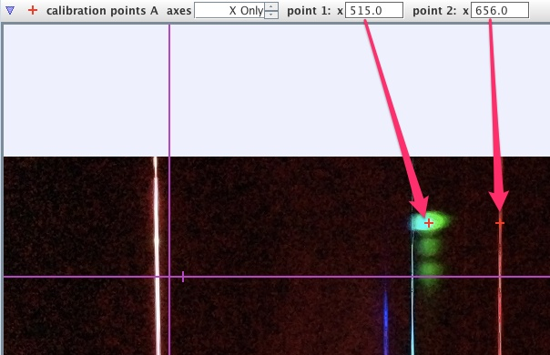
Fig. 6: Hydrogen spectrum with light from LED as reference
- For the line profile, select the region away from the green blobs because the green blobs does not originate from the hydrogen gas.
- Record the wavelengths of the Red, Cyan and Purple lines.
λ_{red} / nm | λ_{cyan} / nm | λ_{purple} / nm

- From Balmer’s experimental data, which you have also just successfully obtained, Rydberg derived a formula for the observed spectral lines
where R_{H} is known as the Rydberg constant.
Determine the Rydberg constant R_{H} from your data.

R_{H} = …………………………….. m^{–1}

- After decades of research, we now know that the visible light emitted from hydrogen is due to the transition of the atom from higher energy state (n > 2) to the 2nd lowest energy state (n = 2) of the atom. The energy of n = 2 state is -3.4 eV.

Discuss how this energy value of the n = 2 state can also be obtained from Rydberg’s formula.

………………………………………………………………………………………………………………

………………………………………………………………………………………………………………

………………………………………………………………………………………………………………

………………………………………………………………………………………………………………

Hence deduce the energy of the n = 1 state.

E₁ = ………… eV

- Determine the value of each energy level of the atom from n = 3 to 5.

E₃ = ………… eV E₄ = ………… eV E₅ = ……………… eV

2.4 Composition of the sun
Using the data from activity 2.1 to 2.3, suggest explain what elements could be present in the sun.

……………………………………………………………………………………………………………………

……………………………………………………………………………………………………………………

……………………………………………………………………………………………………………………

……………………………………………………………………………………………………………………

……………………………………………………………………………………………………………………
Suggested solution

Activity 1
Wavelengths (nm) dips worth recording 656 (H), 589 (He, Na), 540, 536, 532, 526, 517, 502 (He), 491, 486 (H), 431 (H), 397, 393.

- Gas atoms of different elements present in the outer layer of the sun absorb photons with frequencies corresponding to the energies they need to transit from a lower energy to a higher energy state causing excitation.
- When atoms de-excite, photons are emitted in all directions and not necessary towards the Earth. The intensity of the corresponding wavelengths in the continuous spectrum through the grating is lowered which resulted in the formation of “dark lines”.

Activity 2.1
~ 589 nm
- Discrete energy levels in atom
- Energy is transferred by external means to excite the atoms.
- Excited atoms are unstable and de-excite to ground state by emitting photon(s).
- The emitted photons’ frequency depends on the energy difference between the initial energy state E_{i} (of higher energy value) and final energy state E_{f} (of lower energy value) given by

Activity 2.2
~ 502 nm, 589 nm

Activity 2.3
~656 nm, 486 nm, 431 nm

Use the 3 data above to obtain an average Rydberg constant ~1.1 x 10⁷ m⁻¹

Students need to understand that Rydberg Formula is obtained from the energy difference between n > 2 and n = 2. Hence multiple both sides by hc gives a energy conservation relation. The part of the formula related to 1/2² refers to the energy of n = 2. Therefore E₂ = hcR_{H}/2² = 3.4 eV.

It is therefore not difficult to conclude that E₁ = hcR_{H} ~ 13.6 eV

Using formula E = hf to obtain E₃ = -1.5 eV, E₄ = -0.85 eV, E₅ = 0.54 eV

Activity 2.4
The absorption lines at 431, 486 and 656 nm shows presence of H
The absorption lines at 589 (not conclusive) and 502 nm shows He
The absorption line at 589 nm may indicate Na

