Name: _________________ ( ) Class: ______ Date: ______

LIGHT: Reflection
Key Question

1 What is a luminous object and state 2 examples?
2 What are the properties of the image formed in a mirror?
3 How does the eye sees a real object and virtual image.
4 How to draw ray diagrams (cone of light) to represent how an eye sees a real object and virtual image.

Recall – What can you remember about reflection from last year?
Take 2 minutes to write briefly down below.

Puzzle – What are your clarification questions?
Take 2 minutes to write briefly down below.

Activity 1: Teacher’s Demonstration

1 The visualizer shows a candle burning in a beaker.

(a) Predict what happens to the flame when water is added to the beaker and explain why.

(b) Observe the demonstration by the teacher when he pours in the water.
State and explain what happens.

Activity 2:

2 Look onto the table with the ceiling lights on.

(a) State and explain whether you can see the table.

(b) If the room has no light source, state and explain whether you can see the table.

(c) From (a) and (b), state what is a luminous object and is moon a luminous object.

Activity 3

3 Look into the mirror. A reflection of you is seen. The picture shows an object with its image.
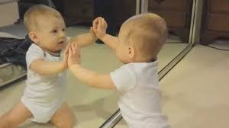

(a) Where is the image located?

(b) State 5 properties of the image formed.

(c) Which type of reflection is this?

Activity 4

The cartoon shows Superman using his X-Ray vision to see a hidden object.
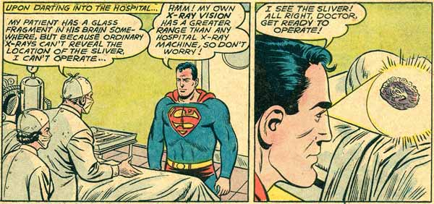

(a) Using concepts of light, suggest how Superman sees an object with his X-ray vision.

(b) State whether you agree or disagree with Supermanʼs science of seeing a real object and explain why.

(c) Draw a ray diagram below on how an eye sees the top and bottom of the candle.

(d) Draw the image of the triangle object and draw a cone of light to show how the eye sees the image.

Activity 5: Data for Reflection of Light

5 Fig. 5.1 shows the setup of a plane mirror with the various angles of incidence, i, (0° to 80°) drawn.

Fig. 5.1
80°
10°
20°
30°
40°
50°
60°
70°

(a) By placing the given light source with the single slit and the plane mirror on fig. 5.1, draw the path of the reflected light.

(b) Measure also the angle of reflection, r and complete the table below.

No. | i / ° | r / °
1 | 10
2 | 20
3 | 30
4 | 40
5 | 50
6 | 60
7 | 70
8 | 80

(c) Plot the graph of i versus r .

(d) State the relationship between i and r.

(e) State the second law of reflection of light and the evidence of the experiment to prove it.

