Name: _______________________________ ( ) Class: ______________ Date: __________

Electromagnetic Induction
Student’s Handout
Topic: Electricity and Magnetism |  | Estimated Duration: 1 hour

- Aim(s)
In this activity, you will get to experience the phenomenon of an induced e.m.f. in a solenoid when there is a change of magnetic flux cutting the coils of the solenoid.
- Materials
  - Datalogger with voltage sensor
  - Magnet
  - Solenoid
  - Scissors
  - Cardboard or paper tube (about 0.8 m to 1 m in height when rolled into a tube)
  - Cotton wool, rag or partially crushed pieces of paper in a cup (For cushioning the drop of the magnet)

In this experiment you will measure the magnitude of the induced e.m.f in a solenoid as you drop a magnet at different heights along the central axis of the solenoid.
1a) Set up the apparatus as shown in the diagram below with the solenoid at the bottom end
of the paper tube.
Datalogger
Crushed pieces of paper or rag in a cup (to cushion impact of magnet)
Voltage sensor
Solenoid
Magnet (midpoint level with the edge of tube and north pole facing downward)
h
Cardboard or paper tube
centre of solenoid
Fig 1

b) Preset the settings of the voltage sensor as follows:
  - Sampling rate : 500 /s
  - Logging duration : 4 s

- Measure the height h from the top end of the tube to the centre of the solenoid and record the value (about 0.800 m to 1.000 m) below.

Height, h = _______ m
This is the height the magnet will drop before passing through the centre of the solenoid.

- Position the magnet with its midpoint level with the top of the cardboard or paper tube and north–pole facing down. Start logging and drop the magnet through the tube. The waveform of the induced e.m.f against time will be displayed on the screen as shown in Fig 3 below.
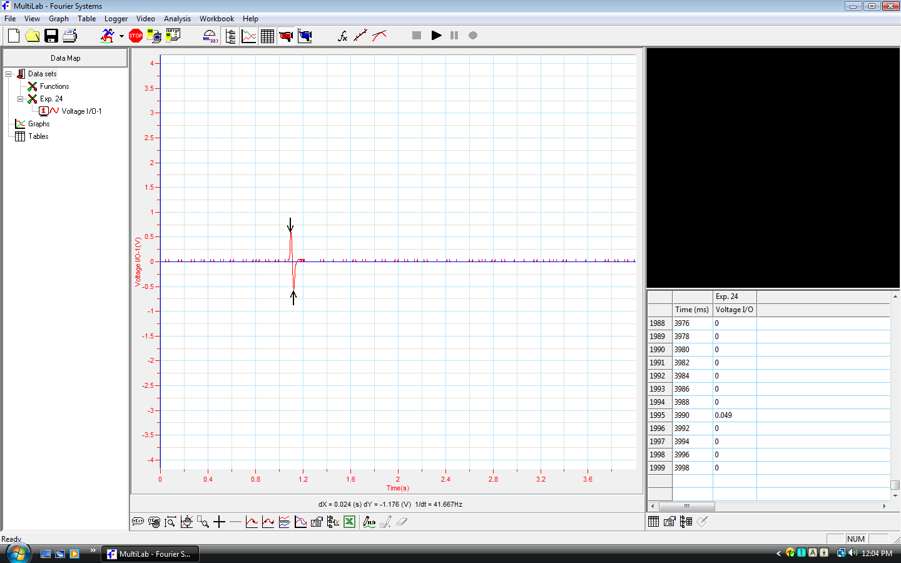

Fig 2

Fig 3

- Click on the maximum and minimum voltages. An upward and downward arrow will appear (Fig 2). Record the peak to peak voltage by reading the dY value at the bottom of the graph (Fig 3). Divide the value by 2 and record this as the induced e.m.f. below.

Induced e.m.f = ________ / 2 = _______ V

- Since the magnet starts from rest, the speed of the magnet as it passes through the solenoid is, v = (2gh)^{½}, where g is the acceleration due to gravity. The speed of the magnet determines how magnetic flux through the solenoid changes. Calculate the speed of the magnet and record the value below.

v =

= ______ ms⁻¹

- Repeat steps 3 to 5. Vary the height of the tube by cutting the tube, and obtain 5 further values of induced e.m.f, E, and speed, v. (Note also how the waveform of the induced e.m.f varies as speed of the magnet decreases).

Height / m | Peak to peak Voltage / V | Induced e.m.f, E / V | Speed, v / ms⁻¹

Discussion based on table of values:
- When the speed of the magnet decreases, does the induced e.m.f increase or decrease?
___________________________________________________________________________
- a) Looking at the values of induced e.m.f and speed, should a graph of induced e.m.f against
speed of magnet pass through the origin? (Hint: What is the induced e.m.f if the speed of
the magnet is zero?)
_______________________________________________________________________________________________________________
__________________________________________________________________________
b) Verify your answer above by connecting a galvanometer to the solenoid and holding the
magnet stationary (speed = 0 m/s) in the solenoid. What is the value of the induced
e.m.f? Does it confirm your answer in (8a)?
_______________________________________________________________________________________________________________
__________________________________________________________________________

Discussion based on plotted graph:
- On the next page, plot a graph of induced e.m.f, E, against speed, v. Draw a line of best fit through the points.
a) What is the relationship between the induced e.m.f, E, and the speed, v?

____________________________________________________________________________________________________________
________________________________________________________________________
b) Given that the rate of change of magnetic flux is directly proportional to the speed of the magnet through the solenoid, what is the relationship between the rate of change of magnetic flux and the induced e.m.f ?

____________________________________________________________________________________________________________
- From the waveform of induced voltage against time in Fig 3 it can be seen that the e.m.f becomes zero at some instant. At this point the whole magnet is inside the solenoid and its centre coincides with the centre of the solenoid. What can you conclude about the rate of change of magnetic flux at this time?
__________________________________________________________________________
__________________________________________________________________________
Further investigations:
- If the magnet is dropped with its south pole first into the solenoid, how would the waveform for induced e.m.f. against time differ? (Hint: compare the negative and positive voltages generated in the two situations)
___________________________________________________________________________
___________________________________________________________________________

- Observe the change in the induced e.m.f. when:
- the number of coils of the solenoid is increased.
- the magnet is changed to a stronger one.

Electromagnetic Induction
Teacher’s notes
Stream: Express |  | Topic: Electricity and Magnetism |  | Estimated Duration: 1 hour

- Description of activity
In this activity, students will study the relationship between the height at which a magnet is dropped along the central axis of a solenoid and the induced electromagnetic force (e.m.f.) in the solenoid.

- Key Idea
The magnitude of the induced e.m.f. is directly proportional to the rate of change of the magnetic flux linked with the circuit.

- Aim
This activity allows students to experience and appreciate the phenomenon of an induced e.m.f. in a solenoid when there is a change of magnetic flux linking the coils of the solenoid. The experimental setup also allows students to make other observations, e.g. how an induced e.m.f. changes with the direction of the magnetic field.

- Objectives
- Related Syllabus Learning Outcome
This lesson exemplar addresses the following learning outcome:
Deduce from Faraday’s experiments on electromagnetic induction or other appropriate experiments that a changing magnetic field can induce an e.m.f. in a circuit
  - Skills and Processes
Students have to be able to manipulate the different apparatus and equipment. They also have to draw conclusions from observations and analysis of the data.
  - 21CC
- CGC – National and Cultural Identity:
The topic of EM induction is closely related to the concept of electricity generation and, in turn, energy issues such as energy conservation and future energy options. A class discussion conducted on this provides students with an awareness of global and local energy concerns, as well as what the individual can do amidst such concerns.
- CIT – Sound Reasoning:
Students practise sound reasoning when they draw conclusions about the phenomenon of EM induction from their experimental data and observations.

- Prior knowledge
Students have learnt to:
  - state that kinetic energy Ek = ½ mv² and gravitational potential energy Ep = mgh (for potential energy changes near the Earth’s surface),
  - state the properties of magnets, and
  - compare the use of non-renewable and renewable energy sources such as fossil fuels, nuclear energy, solar energy, wind energy and hydroelectric generation to generate electricity in terms of energy conversion efficiency, cost per kW h produced and environmental impact

- Materials
  - Datalogger with voltage sensor
  - Magnet
  - Solenoid
  - Scissors
  - Cardboard or paper tube (about 0.8 m to 1 m in height when rolled into a tube)
  - Cotton wool, rag or partially crushed pieces of paper in a cup (For cushioning the drop of the magnet)
  - Titles and descriptions for some YouTube videos showing alternative energy sources:
- Wave power by newscientistvideo:
Electricity generation techniques inspired by movement of sea creatures in the ocean (Biomimicry)
- CraftEngine – Electricity production from renewable heat sources:
Electricity generation using biomass combustion, solar thermal and waste heat.
- Solar Energy Tower:
Solar towers capture solar energy to heat air under a collector zone. Based on the convection principle that hot air rises, this air flows towards the center of the collector through turbines and up and out of the tower. The flow of air through the turbines generates electricity.
- Solar Islands
Solar panels are built over the oceans to absorb heat from the sun to produce steam. This steam is then transferred via pipelines to onshore power plants to generate electricity.

- Suggested lesson guide

Assessment indicators | Lesson Activity | Pedagogical Considerations
Evidence of learning is shown when students are able to….  - compare different  energy options in terms of energy conversion efficiency, production cost and environmental impact.  - describe some  commonality behind the various methods of electricity generation, e.g. it involves magnets, there is movement or kinetic energy at the start of the energy conversion chain etc. | Lesson Introduction ..  - Show students videos of interesting and innovative ways of electricity generation. In addition, refer them back to what they have learnt about renewable and non-renewable sources of energy used for electricity generation. (URL to videos can be found under the Materials list).  - Questions and pointers for discussion:  - Discuss about issues pertaining to energy conservation and future energy options, both locally and internationally. Get them to compare the different energy options.  - Ask students to discuss about the common principle behind the various methods of electricity generation.  - Inform students that the activity which follows will allow them to experience how a change of magnetic flux results in an induced e.m.f. in a solenoid. | This discussion provides purpose for the next activity, and ensures that students do not learn about the concept of electromagnetic induction separate from the authentic context of electricity generation and the bigger energy issues.  21 CC:  The energy issue is a global concern; the discussion on renewable and non-renewable energy sources leads to teachable moments on issues pertaining to energy conservation and future energy options.
Evidence of learning is shown when students are able to….  - verbalise that a changing magnetic field induces an e.m.f. in a circuit.  - conclude that the magnitude of the induced e.m.f. is directly proportional to the rate of change of magnetic flux. | Lesson Development ..  - Distribute student’s handout (Electromagnetic Induction). Students perform the experiment based on the instructions on the student’s handout.  - Students made observations of the experiment to answer the following questions:  - How does the magnitude of an induced e.m.f. change with the speed of the falling magnet, and hence the rate of change of magnetic flux?  - What happens to the induced e.m.f. when the magnet falls with the opposite pole first?  - What happens when the speed of the magnet is zero or there is no change in the magnetic flux linking the coils? | 21 CC:  Students have to draw conclusions about the phenomenon of EM induction through analysis of their experimental data and plotted graph.
 | Lesson Closure ..  - Inform students that what they have experienced is known as Faraday’s Law which states that the magnitude of the induced e.m.f. is directly proportional to the rate of change of the magnetic flux. | Students get to experience the phenomenon first before it is formally introduced as a physics law. This gives more meaning than simply stating and describing the law.

- Additional notes for teacher
- Some common misconceptions on Electricity and Magnetism
Students often think that:
- Charges at rest can experience magnetic forces
- Magnetic flux, rather than change of magnetic flux, causes an induced e.m.f.
- Voltage can only be induced in a closed circuit
Refer to Handbook for Teaching Secondary Physics (Chapter 8) for more on the teaching of Electromagnetism.

- Teachers who wish to further develop the lesson using ICT features can consider the following simulations:
- http://www.phy.ntnu.edu.tw/ntnujava (Search for “Long magnet falling through solenoid”)
This is an EJS Open Source long magnet falling through solenoid model java applet.
- http://web.mit.edu/jbelcher/www/java/falling/falling.html
This applet shows the magnetic fields of a permanent magnet as it falls through a non-magnetic copper ring.

- Suggested answers
7 | The magnitude of the induced e.m.f. decreases with the speed of the magnet.
8a | The graph should pass through the origin.
8b | There should not be an induced e.m.f. when the magnet is held stationary in the solenoid.
9a | There is a directly proportional relationship between induced e.m.f and the speed of the falling magnet. (Note: E = BLv where B is the perpendicular flux density of the magnetic field and L is the length of the conductor).
9b | The induced e.m.f. is directly proportional to the rate of change of magnetic flux.
10 | There is no change to the magnetic flux, therefore the induced e.m.f. becomes zero.
11 | The positive and negative voltages for the second waveform (magnet dropped with South pole first) will be opposite to that for the first waveform.

- Acknowledgement
This lesson was developed with feedback from Mr Wee Loo Kang (Senior Specialist, Education Technology Division, Ministry of Education)

