Name: | ____________________________ | Class _______________
Subject: | Physics | Time: 90 mins
Worksheet Title: | Direct Current Electrical Motor Model – Virtual Laboratory

Aim: To investigate dc motor model

Apparatus: Computer with DC Motor java applet
http://www.phy.ntnu.edu.tw/ntnujava/index.php?topic=1266.0

Background:
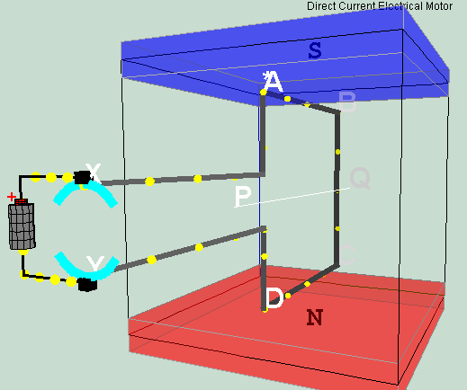
battery
Split rings
Split rings
brush
brush
Rotating coil
C
B
Y
X
Q
Figure: Direct Current Electrical Motor Model in external magnetic field Bz direction and a electric circuit with battery, brush, split rings and a rotating coil.
Electric motors turn electricity into motion by exploiting electromagnetic induction. A current-carrying loop that is placed in a magnetic field experiences a turning effect. A simple direct current (DC) motor is illustrated here. ABCD is mounted on an axle PQ. The ends of the wire are connected to a split ring commutator at position X & Y. The commutator rotates with the loop. Two carbon brushes are made to press lightly against the commutators.
The motor features a external magnet (called the stator because it’s fixed in place) and an turning coil of wire called an armature ( rotor or coil, because it rotates). The armature, carrying current provided by the battery, is an electromagnet, because a current-carrying wire generates a magnetic field; invisible magnetic field lines are circulating all around the wire of the armature.
The key to producing motion is positioning the electromagnet within the magnetic field of the permanent magnet (its field runs from its (bottom) north to (top) south poles). The armature experiences a force described by the left hand rule. This interplay of magnetic fields and moving charged particles (the electrons in the current) results in the magnetic force (depicted by the green arrows) that makes the armature spin because of the torque.
Use the slider current I to see what happen when the flow of current is reversed.
The checkbox current flow & electron flow allows different visualization since I = d(Q)/dt and Q= number of charge*e.
The Play & Pause button allows freezing the 3D view for visualizing these forces, for checking for consistency with the left hand rule .
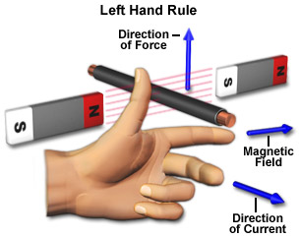
Figure: A typical Left Hand Rule apply to this context, students need to re-orientate the hand and apply to the DC motor context accordingly (diagram by National High Magnetic Field Laboratory)
A swing back and fro motion (maybe θ = 0º to 180º and 0º) is all you would get out of this motor if it weren't for the split-ring commutator — the circular metal device split into parts (shown here in teal color with a gap of β2) that connects the armature to the circuit. Electricity flows from the positive terminal of the battery through the circuit, passes through a copper brush to the commutator, then to the armature.
When the current is positive, current runs through ABCD as shown in the diagram (select the checkbox labels?), a +y direction force would act on AB. An -y direction force would act on CD. Taking moments about the axle, reveals a resultant torque T = F_{mag}*AD*cosθ acts on the coil loop. The coil loop in an clockwise manner (view from battery side) until it reaches the θ = 80º position (assuming that split ring angle are default at (β2 = 80º). At this θ = 80+º position, the current is cut off. However, the momentum of the loop carries it past the horizontal position until the coil loop reaches θ = 110º position. Contact between loop and split ring commutator is established again and the current in the coil loop is now reversed. A -y direction force now acts on AB while a +y direction force acts on CD. The rotation motion is reinforced clockwise (view from battery side) as θ continues to rotate from 110º to 260º. At this θ = 260+º position, the current is cut off. However, the momentum of the loop carries it past the horizontal position until the coil loop reaches θ = 280º position. Contact between loop and split ring commutator is established again and the current in the coil loop is now reversed back to same as from θ = 280º to 80º. A +y direction force would act on AB. An -y direction force would act on CD and the loop reaches θ = 0º . The cycle repeats after θ = 0º allowing the armature to experience torque in the reinforced direction at the right time to keep it spinning.
The purpose of the commutator is to reverses the direction of the current in the loop ABCD for every half a cycle.
Engage: Ever wonders how a motor works? You can better understand the principles of a DC motor and maybe even assemble one yourself at home using simple equipment like battery, a few wires, and permanent magnet. Watch physicists Becky Thompson-Flagg and Ted Hodapp trade quips as they show how to take apart a small DC motor and find out how it works by American Physical Society. http://www.youtube.com/watch?v=Q_sR697b0JE

Explore:
- Select the play button to start the simulation.
- Reset the simulation by clicking on reset button.
- Explore the sliders each and write down as clearly as you can to explain what each slider controls.
Hint: try to figure out by yourself and put your cursor over the slider for the help text to check if you need help

β2:

i: current in the circuit as provided by the battery flowing a closed loop, direction is as flowing out from the positive terminal of the battery and back to the negative end.

Bz:

Vary Bz slider until it is negative, what is the direction of the Bz then?

Lx:

Lz:

Ff:

Inertia:

N:

- As the simulation is explored, notice also how these variables change. Suggest with physics and mathematics reason, what they are.

Hint: try to figure out by yourself and put your cursor over the slider for the help text to check if you need help

θ: angular displacement of the coil or armature ABCD as determined by the angle between the area vector of ABCD and direction of upwards Bz field

ω:

α:

FBy:

TB:

Explore Activity A:
- The current comes from the battery higher potential end and travels in a wire forming a closed circuit and travels back to the lower potential end of the battery. When θ = 90º current flows from the battery higher potential end, to the top brush, to the Top split ring, through the coil loop in order ABCD, back to bottom split ring, bottom brush and lower potential end of the battery (refer to actual simulation).
- State the direction of Bz when it is use as +0.8 T.

  - When I = 1.2 A, what is the direction of the current flow in wire AB?
Hint: use in positive x, positive y, positive z direction instead of left and right which is less clear as it depends on the viewers’ perspective.

  - When I = 1.2 A, what is the direction of the current flow in wire CD?

  - using Fleming's left-hand rule, deduce the relative directions of force acting on. Draw an arrow with its usual meaning → on each of the 3 views Front, side and Top view to represent each section.
hint: note that F_{mag} = i*B*L*sin(i&B) may be useful

    - AB
    - CD
    - BC
    - DA.
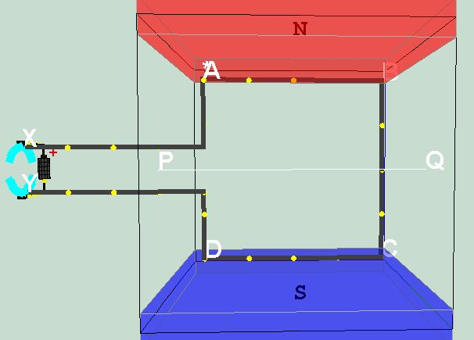 | 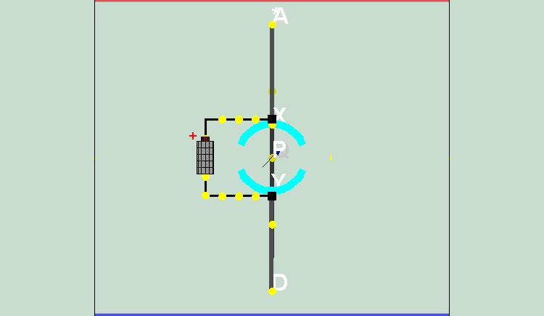
Front view | Side view
Sketch your Bz direction and answers to i, ii, iii, iv as clearly as possible
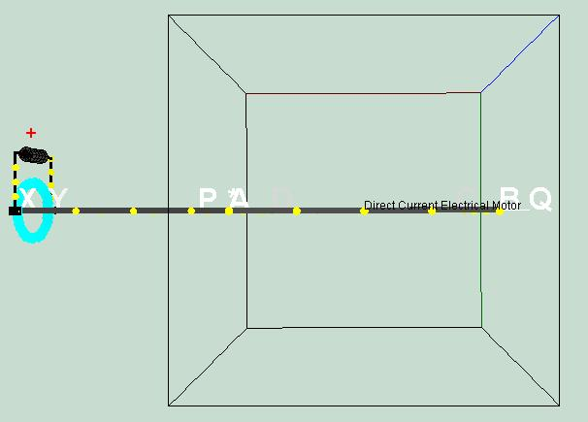
Top view

- At this particular angle θ = 90º by taking moments about the axle PQ, consider the forces on AB and CD, deduce the direction of the torque τ as view from the side view or otherwise, and the motion if the coil loop was initially at rest (ω = 0 deg/s). Show your working clearly.

- Select the suitable sliders of your choice and verify your hypothesis about the equation for τ for 2 other angles. Show the 2 other angles working clearly. Discuss with your partner what you have discovered. Ask your teacher if there are any problem/issues faced using this virtual lab

- Explain and show the equations involving torque τ ( in earlier part of question), why the forces on wire BC and DA did not contribute to the calculation of rotating torque about axle PQ?

- By considering the forces in the x direction for wire BC and DA, suggest what can happen to the coil loop if the forces are large enough.

- Suggest why it does not happen in terms of the properties of the wires in the coil loop.

Explore Activity B:
- Design an experiment using the simulation model to explain how a current-carrying coil in a magnetic field experiences a turning effect and investigate the effect is increased by increasing (i) the number of turns on the coil, (ii) the current i (iii) increasing the magnitude of the external Bz field.
Show clearly for one row, the formula used and substitution from the values
number of turns  N | Current  i / A | Magnetic field  Bz / T | Max. Magnetic force on wire AB  FBy / N | Max. Torque on coil ABCD  τ / Nm
- After conducting some inquiry learning on the virtual DC motor model discuss how this turning effect is used in allowing the coil loop to rotate.

- Change the angle of the splitring be varying β2 to 30º and run the simulation. Observe and note down what happens to the coil’s motion with a smaller splitring.

- Uncheck the checkbox splitting? and run the simulation. Observe and note down what happens to the coil when there is no split ring present.

- Hence or otherwise, describe the action of a split-ring commutator in a two-pole magnet setup, single-coil motor.

- Suggest the effect of adding a soft-iron cylinder in the winding the coil.

Extend Problems:
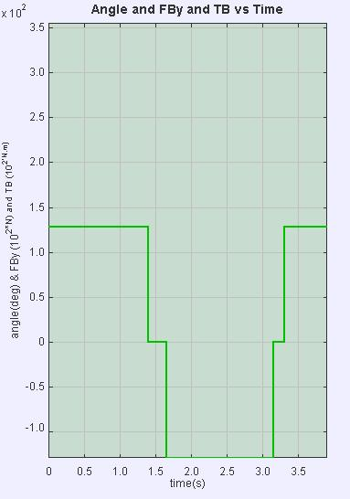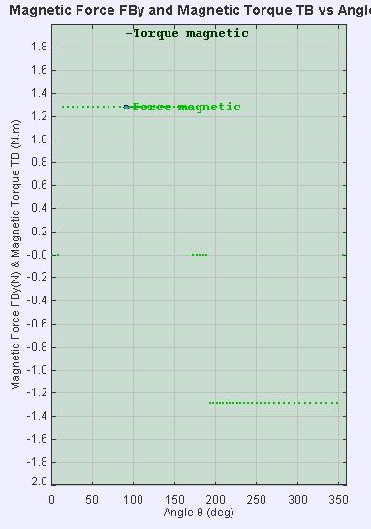
- Suggest with reason, why the graph of FBy vs time becomes zero at time = 1.4 to 1.6 s and 3.2 to 3.3 s (left graph) angle = 170º to 190 º as shown in the graph (right) above.

- Suggest with reason, why the graph of FBy vs time becomes negative at time = 1.6 to 3.2 s as shown in the graph above.

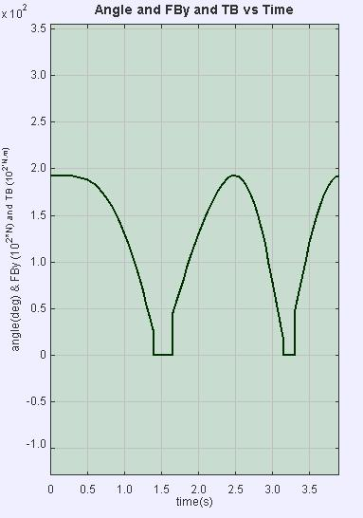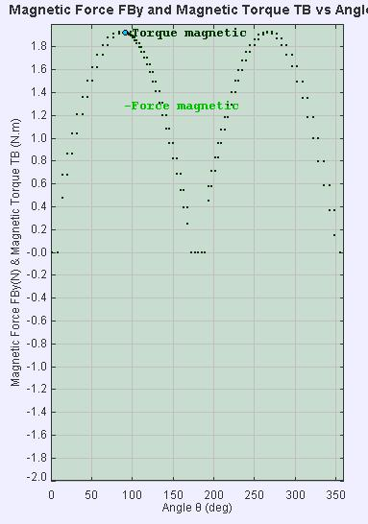
- Suggest with reason, why the graph of τB vs time in the shape as shown? In your explanation, highlight why the n shape, the sudden drop to zero torque and asymmetrical shape of the n. (run your own simulation to investigate this)

- Vary the Ff slider and re-run the simulation each time to explain what is the impact of having frictional force on the motion of the DC motor.

- Uncheck the Current flow to Electron flow checkbox and suggest what the relationship between current flow and electron flow is.

- The meaning of Inertia is unknown; suggest with reason the meaning of it in this simulation.

- Given that the formula F = IBL sin (I & B) suggest a variable that is L in this simulation.

- Given that the formula τ = Σ F.d cos (cta) derive the meaning of d and cta used in this simulation.

- To build a real dc motor the materials required are:
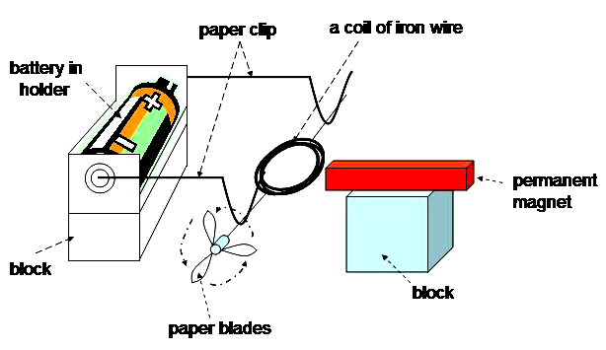
  - 1 x Battery D size with battery holder
  - small coil of copper wire
  - 2 paper clips
  - 1 x permanent magnet
  - glue
  - a pair of scissors
  - sandpaper
  - some block of wood (optional)
  - paper blades (optional)
- Put the battery in a battery holder.
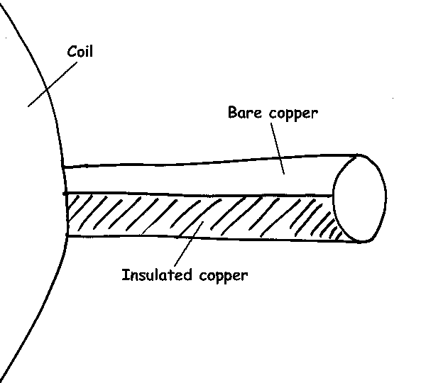
- Bend the paper clips to make a hook at each end, and attach to the battery holder as shown above.
- Place the coil of iron wire onto the cradles, leaving at least 1 cm of wire away from the cradles. Cut off if there is any excess.
- With the sandpaper remove the top half of the insulation from both free ends of the wire in contact with the paperclips.
- Adjust the cradles till the coil spins nicely on the cradle.
- Place a permanent magnet near to the coil.
- Adjust the height of the magnet till the center of the magnet is aligned with the center of the coil.
- Move the magnet closer to the coil
- Spin the coil gently and observe

Suggestion(s) to improve the computer simulation?

Suggestion(s) to improve the worksheet activity?

Any comments?

