Name: …………………………………………… Class: ……… Date: ………………

What happens when you drop a magnet through a coil?

Scenario
A bar magnet is dropped so that it falls freely through the coil as shown in Fig. 1. The voltage output (induced emf) from the coil is measured by a data logger connected across the ends of the coil. These data are processed to give a graphical printout of the results obtained.

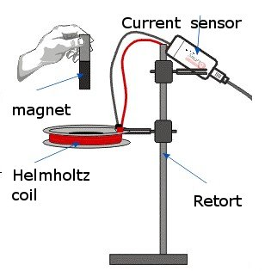
Fig. 1

Prediction (10 minutes)
Sketch your predicted variation of the flux linkage and induced emf across the coil with time. Explain how both sketched are obtained, you should include any subtleties that are depicted in your sketches.

______________________________________________________________________________
______________________________________________________________________________
______________________________________________________________________________
______________________________________________________________________________
______________________________________________________________________________
______________________________________________________________________________
______________________________________________________________________________
______________________________________________________________________________
Observing the experiment with simulation (45 minutes)
Let us investigate the factors affecting the induced emf across the inputs of the coil with the help of an applet simulation. Author of computer model (applet): Loo Kang, Lee Tat Leong and Francisco Esquembre (original author)

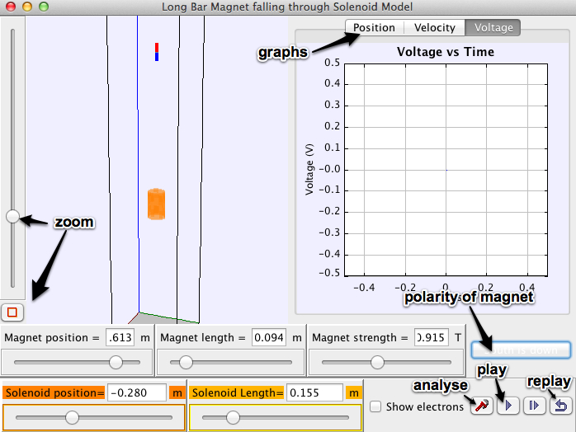
Fig. 2: User controls of the simulation

(A) Getting started with the simulation
- Set the magnet position to 0.8, magnet length to 0.05, magnet strength to 2.5, fix coil’s height and coil’s length to be 0.00. (You may want to check the “bottom view” button to see magnet and coil from the far view)
- Click on the “play” button to drop magnet through the coil until the end.
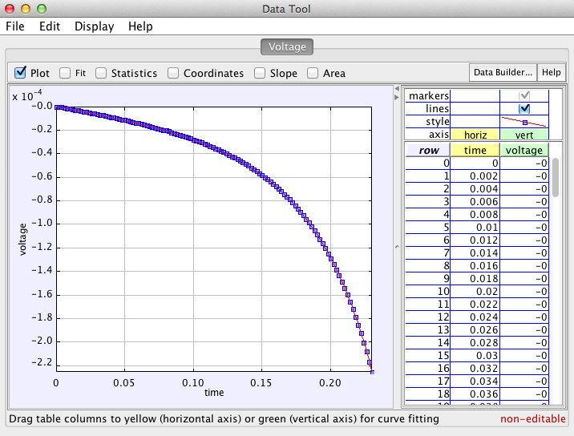
Fig. 3: Analysis tool of the V-t graph
- Click on the “analyse” button  to obtain a detailed V-t graph (see Fig. 3).
- Sketch the actual V-t graph (refer to as Graph 1 for this activity) that you obtained in the blank space below.
- Check on the “coordinate” box and bring your cursor to the peaks of Graph 1. Record the peak values of the induced e.m.f.
  - Are the induced peak e.m.f of the same magnitude?
  - Explain the observation.
________________________________________________________________________
________________________________________________________________________
________________________________________________________________________
________________________________________________________________________
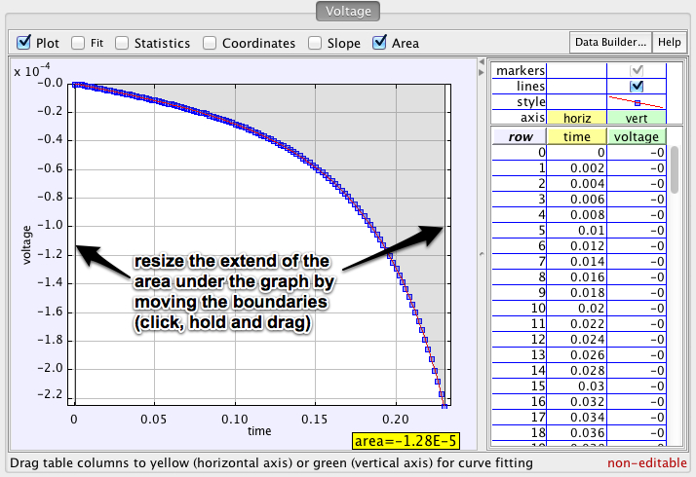
Fig. 4: Finding the area under graph
- Uncheck the “coordinate” box and check on the “area” box and record the values of the areas under the different distinct regions in Graph 1.
  - area 1 = ……………… area 2 = ………………
  - State the unit of the area. Explain how you arrive at the answer.
________________________________________________________________________
________________________________________________________________________
________________________________________________________________________
  - Calculate the difference in the areas. Comment on the value obtained.
________________________________________________________________________
________________________________________________________________________
________________________________________________________________________

- Close the data tool window. Check on , extend the solenoid length and zoom into the coil. Click the “restart” button and play the simulation. Observe the movement of free charges (which have been numbered for easy reference) in the ring as the magnet enters and leaves the coil. State and explain the direction of motion of these charges.
________________________________________________________________________
________________________________________________________________________
________________________________________________________________________
________________________________________________________________________
(B) Changing Polarity of Magnet, Keeping All Other Variables Constant
- Change the polarity of magnet while keeping magnet height as 0.80, magnet length as 0.05, magnet strength 2.50 and coil’s height and length to be 0.00.
  - Sketch Graph 2 below.

  - Compare Graphs 1 and 2. Explain any difference and similarity.
________________________________________________________________________
________________________________________________________________________
________________________________________________________________________
________________________________________________________________________

(C) Changing Height of Magnet, Keeping All Other Variables Constant
- Change the polarity of magnet back to step 1. Change the height of magnet keeping magnet length as 0.05, magnet strength as 2.50 and coil’s height and length as 0.00. Run the simulation again.
- Repeat steps 2 to 6 to obtain
  - a sketch of Graph 3,
  - the peak values,
  - areas under the different distinct regions in Graph 3 and difference in these areas,

  - Compare Graph 1 and 3 for the peak values and the areas under the graphs. Explain the any similarities and differences.
Peak values ___________________________________________________________
_____________________________________________________________________
_____________________________________________________________________
_____________________________________________________________________
Areas ________________________________________________________________
_____________________________________________________________________
_____________________________________________________________________
_____________________________________________________________________
(D) Changing Strength of Magnet, Keeping All Other Variables Constant
- Now, reset the height of magnet to 0.80 and keeping the polarity as “South is down”, magnet’s length as 0.05 and coil’s height and length as 0.00. Increase the strength of the magnet.
- Repeat steps 2 to 4 to obtain
  - a sketch of Graph 4,

  - State and explain the difference between the shapes of Graph 1 & Graph 4.
________________________________________________________________________
________________________________________________________________________
________________________________________________________________________
________________________________________________________________________
  - If the strength of the magnet is decreased, deduce the new V-t graph. Explain your deduction.

________________________________________________________________________
________________________________________________________________________
________________________________________________________________________
________________________________________________________________________

(E) Changing Length of Coil (ie Solenoid), Keeping All Other Variables Constant
- Now, reset the length of magnet back to 0.05 and keeping the height of magnet as 0.80, magnet strength as 2.50, polarity as “South is down” and coil’s height and length as 0.00. Set the length of the coil to 0.740 (ie becomes a solenoid in this case).
- Obtain a sketch of Graph 5. Compare Graph 1 and 5 and explain the differences

________________________________________________________________________
________________________________________________________________________
________________________________________________________________________
________________________________________________________________________
Post activity question (15 minutes)
The actual V-t graph obtained from the data logger is as shown in Fig. 5.
Fig. 5
Answer the following questions in the blank space below.
- Explain why the curve slopes upwards from A to B.
- Explain why the voltage shown at B has a smaller magnitude than the voltage shown at D.
- Explain why the graph has a positive and a negative section.
- The areas under the two segments of the curve are the same. Explain why this is so.

Reflection of activity (5 minutes)
Please provide some feedback, in the space provided below, of your experience with the activity. Your feedback will help us to improve the activity for future use. Thank you.

