Blended Learning Innovation in Physics Learning of Electromagnetic Induction

¹Loo Kang WEE, ²Charles CHEW, ³Raymond TSOI, ⁴Kah Chye TAN
¹Ministry of Education, Education Technology Division, Singapore
²Academy of Singapore Teachers, Ministry of Education, Singapore
³Institute of Education, Nanyang Technological University, Singapore
⁴Addest Technovation,, Singapore
wee_loo_kang@moe.gov.sg, charles_chew@moe.gov.sg, raymond.tsoi@nie.edu.sg, kctan@addest.com

Abstract: Based on concept of distributed leadership with different expertise, a tripartite partnership involving a Physics Master Teacher and an Educational Technology Officer from MOE, a NIE Assistant Professor and a Scientist from a local data-logger company designed and developed a blended learning lesson exemplar on a highly abstract topic of Electromagnetic Induction for Junior College teachers and students’ use. The outcome of this tripartite collaboration is a three-prong innovation comprising (a) the creation of real life data-logger experiments to situate scientific concepts in the physical world for face-to-face learning, (b) the customization of computer simulations from the Open-Source-Physics community to facilitate construction of scientific concepts through online learning and (c) the use of the TSOI Hybrid Learning Model as a pedagogical framework for meaningful Blended Learning to integrate the face-to-face learning and online learning.
Keyword: physics education teacher professional development integrated e-learning applet learning community open source self directed learning collaborative ICT masterplan 21st century skills modelling teach less learn more thinking school nation

Introduction
The concepts in electromagnetism induction are difficult concepts for many students, due to a combination of many factors, one of the main causes is the difficulty to “make sense” of the phenomena, without reference to “real-life referents” , thus, leading to what is commonly referred to as abstract nature of learning physics.
Many educational researches have rightly focused on addressing difficulties in learning to be supported by computers especially in harnessing technology to support learning-by-doing . Appropriate use of computers are arguably micro computer based laboratory (MBL) or data-logging , and perhaps more prominent in recent times, computer simulations as virtual laboratory .
We present a blended learning lesson exemplar on the abstract topic of Electromagnetic Induction for Junior College teachers and students’ by using both real equipment with computer simulation that aims to bring the best of the real world and the computer world, guided by a TSOI learning cycle or model for supporting productive integration.
We hypothesize that lessons with such innovation that comprise of (a) real life data-logger experiments to situate scientific concepts in the physical world for face-to-face learning, (b) complementary customized computer simulations to facilitate construction of scientific concepts through online learning and (c) use of learning model such as the TSOI Hybrid Learning Model as a pedagogical framework for meaningful blended learning to integrate the face-to-face learning and online learning. This may be seen as part a key trend in horizontal report on open content and educational resources for Physics learning that is worth exploring for teachers and policy makers in Ministry of Education.

Current Situation

Challenges faced by teachers in the Digital Age
1. Lack of pool of cost effective real life experiments and support
The challenge of reduced usage of physics practical experiments using data loggers in favor of more easy to implement physics experiments suited for the assessment of science practical assessment (SPA) skills. The learning and assessment of SPA can be implemented in our lesson exemplar due to the 1) strong support of a dynamic local data logger Singapore home grown company, 2) highly reliable data logger sets from Addest Technovation Pte Ltd, 3) customized demo sets and 4) durable and easy to replace everyday school laboratory apparatus. Our lesson exemplar is conceptualized with lesson design, implementation and assessment in mind and thus, better poised to lower the barrier to adoption by teachers and schools.
2. Lack of matching online syllabus-customized simulations for active and inquiry learning
Last challenge we are addressing is the limited pedagogical use of computer video, animations and simulations from the internet such as using as a demonstration for visualization purposes. In addition, many teachers are using non-customizable simulations of varying quality and pedagogical features created by the original authors of the simulation. Another e-learning trend is the quick fix solution to e-learning management system available to local schools from commercial vendors. A quick investigation on a particular vendor subscription based contents revealed that the content are predominantly instruction based materials. We argue that these animated voice type of PowerPoint presentations do not encourage learning by doing necessary for bootstrapping understanding and knowing. To address these 2 issues of non-customizable simulation of varied quality and limited pedagogical features in existing WWW simulations and the e-vendor produced curriculum materials that assumes knowledge can be largely delivered to the students, we customized simulations for active and inquiry learning purposes. This matching online simulation is also created with the design, implementation and assessment stages in mind.
3. What is the suitable blended?
Teachers of today face challenges to engage Generation Z learners in the digital age that expect and need the use of technology to be part of the lesson. This has lead to teachers using digital applications for array of purposes, with some usage more pedagogically sound than others. Many teachers are bombarded with tools such as knowledge building software (wiki, blogs, knowledge forum), concept mapping tools (Cmap, Webspiration) communication tools (Facebook, Twitter) and production tools (YouTube, Glogster), and usually usage of these tools could be so fore grounded that the actual doing and experimenting of physics is assumed to have occurred. We argue that to learn physics deeply, the students have to foreground the actual doing and experience the physics personally, in order for subsequent use of other tools mentioned earlier to be meaningful.

Current solutions and practices in the use of technology-supported lessons
1. Lack of pool of cost effective real life experiments and support – There are no customized experiments solutions with strong local support team. Most other reputable data logger companies are based overseas with sales office and limited product support team.
2. Lack of matching online syllabus-customized simulations for active and inquiry learning - There are no suitable solutions available. Some schools have engaged vendors to produce simulations but the low quality and questionable scientific accuracy of some of the simulations, have left many teachers using free-internet simulations. There are some university research simulations of high quality but it is difficult to find matching and complimenting simulations for every real life experiments using data loggers.
3. What is the suitable blended learning? - It is our perception that many teachers continue to just conduct face to face lessons, without significant integrative online learning. Schools in Singapore are fortunate to be well equipped with numerous stand-alone ICT tools for teachers in planning ICT-supported lessons. Unfortunately, some teachers may not be able to conduct online learning experience as well as face to face classroom learning. Thus, we argue that many e-learning lessons are either stand alone, not well connected to the face to face lessons or just uploaded as lectures notes and video presentations that serve as a repository of lesson archives. On a more positive note, in our interaction with teachers, we also found some teachers are supportive of the notion of blended learning. For these teachers, a learning cycle that is easy to use and evidence-based will give them the guidance and support to blend learning.
4. Why did we design our lesson exemplar idea and not use existing solution? As mentioned in B1 – B3 and in other words, the absence of customized to Singapore curriculum, real life experiments with data loggers and online computer simulations for inquiry based learning, for effective blended learning.

Literature Review

Blended learning is about a mixture of instructional modalities, delivery media, instructional methods, and web-based technologies . Combining the best elements of e-learning or online learning and in-person or face-to-face learning, blended learning is likely to emerge as the predominant mode of teaching and learning to engage today’s digital native students who expect their learning environment to include technology. Table 1 below shows the blended learning continuum from the traditional face-to-face learning to fully online learning.

Table 1: Blended Learning Continuum and its application to Singapore classrooms
Fully Face-to-Face learning Fully Online learning

Traditional face-to-face setting with few or no online resources | Classroom Instruction integrating online resources, but limited or no requirements for students to be online | Classroom Instruction with significant, required online components that extend learning beyond the classroom and beyond the school day | Mostly or fully online curriculum in computer lab or classroom where students meet everyday | Mostly or fully online curriculum with select days required in computer lab or classroom | Fully online curriculum with options for face-to-face instruction, but not required | Fully online curriculum with all learning done online and at a distance and no face-to-face
Many lessons | Some lessons | A possible meaningful blended learning suitable for Singapore physics curriculum |  |  |  | Not recommended for Singapore lesson due to the fact that Singapore is well connected country
Numerous ways of using blended learning that can be incorporated successfully into the classroom

Three main benefits of blended learning in education:

Pedagogy for Active Learning
Blended learning provides pedagogical richness towards active learning for Generation Z learners. In today digital world, the harnessing of the right available technologies and tools is likely to better engage and meet the needs of the Generation Z students of the 21st century. Ms Ho Peng, the then DCPD who is the current DGE said in the 2007 Curriculum Forum:

“The interactive nature of digital media will transform not just the way we teach, but more significantly, how students will learn – they will not just be passive recipients, but more fully participate in their own learning.”

Matching of Delivery to Subject Matter Knowledge to Learners
Research has illustrated that it is critical that the methods of delivery match the subject matter knowledge and audience. However, finding one match for everyone is not possible. Instead a blend of approaches and methods is critical to achieve maximum learning across a variety of learners. Only a blend of methods and approaches can produce the richness and achieve the desired learning outcomes.

Increased Access and Flexibility
Blended learning provides greater access to personalized learning, to resources and experts. Having an online learning component besides face-to-face will allow learners to access learning anywhere and anytime. In addition, the online learning will facilitate a self-paced learning whereby the faster learner can proceed further while the slower learner can proceed at their own pace of learning. The Online learning also allows the option of learners staying at home without travelling down to the school especially in situations such as SARS. There is also the advantage of reduced physical laboratory space. In addition, blended learning allows greater accommodation for learners and teachers of diverse backgrounds.

Case for TSOI Model as an innovative pedagogical framework for Blended Learning
In view of the lack of research evidence-based ICT-based pedagogical models, the team decided to adopt the TSOI Hybrid Learning Model developed by one of the team members, Dr Raymond Tsoi, of the National Institute of Education.
The reason is that the TSOI Hybrid Learning Model (HLM) is a research evidence-based model which represents learning as a cognitive process in a cycle of four phases: Translating, Sculpting, Operationalizing and Integrating (Figure 1).

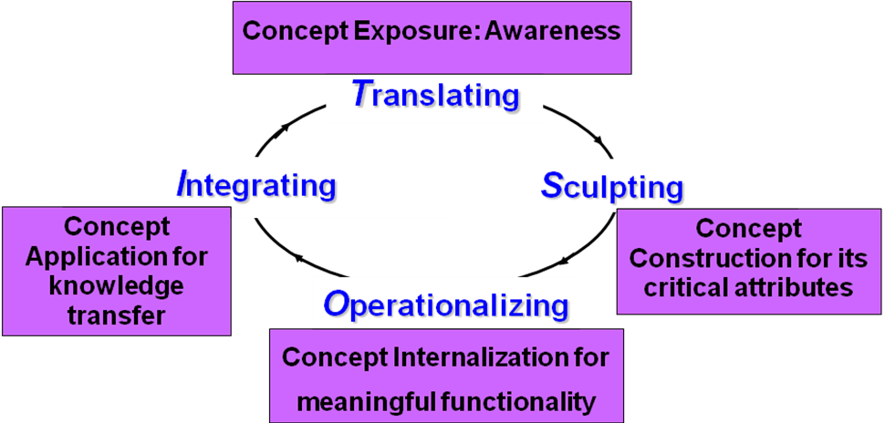

- The TSOI Hybrid Learning Model

The unique core of the hybrid learning model is meaningful, functional and relevant for the blended learning experiences. The model represents learning as a cognitive cyclical process of four phases: Translating (experiences translated to a beginning idea of the concept), Sculpting (concept constructed for its critical attributes), Operationalizing (concept internalized for meaningful functionality) and Integrating (concept applied for meaningful transfer of knowledge). Constructivist and inquiry-based, the model advanced from Science learning cycle model and Kolb’s experiential learning cycle model addresses concept learning and learning styles.
Data loggers are useful tools for the face-to-face components of blended learning by providing students with both hands-on and minds-on learning experiences with present-day technology. With automatic data collection and graphing, data logging allows students to spend more time on interpreting data to identify trends and patterns
Simulations are also useful tools for learning as students can continue to interact and learn physics at home. This will help to overcome the challenges that students cannot continue to interact and learn with physics laboratory apparatus outside school. Though lending out school data loggers for science inquiry could be a solution, there is a risk of damaged and missing apparatus without close supervision

Implementation
Based on the TSOI Hybrid Learning Model described earlier a blended learning exemplar on the abstract topic of Electromagnetic Induction is designed and illustrated below.
Phase 1 on Translating: Face-to-Face demonstration of real model of producing electricity from magnetism from a hand-held ac generator (Figure 2. ) for concept exposure to create awareness in an experiential manner. The experiences are translated to a beginning idea of the concept.
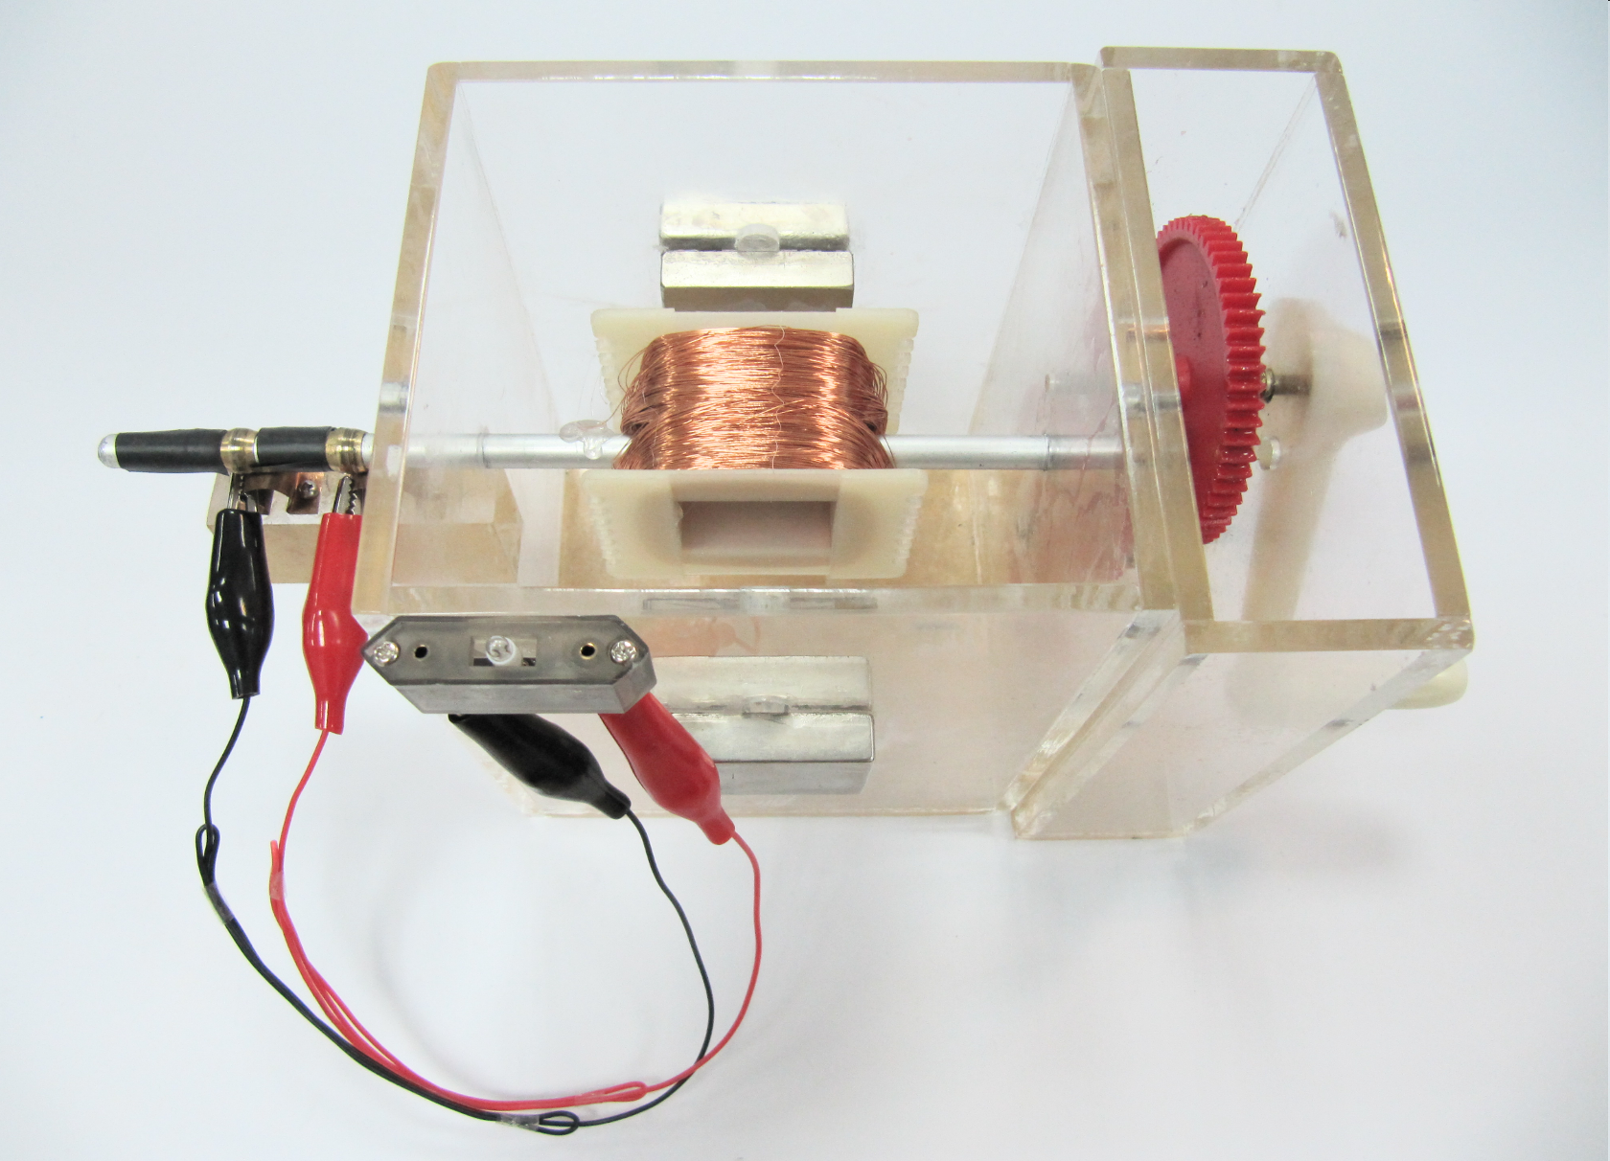

- Real-life AC generator demonstration set by Scientist Dr Tan Kah Chye (2010)
Phase 2 on Sculpting: Face-to-Face data logger based investigation for concept construction for its critical attributes
Essence of the Data logger-based Investigation

Learners will first collect a few sets of data using data logger (Figure 3. ), each of which facilitates a preliminary understanding of one aspect of Faraday or Lenz’s Laws of Electromagnetic Induction. After such a preliminary understanding of Faraday and Lenz’s Laws is attained, they will account for some crucial characteristics of fairly complex Electromagnetic Induction graphs obtained under different scenarios, leading to conceptual understanding of the 2 laws.
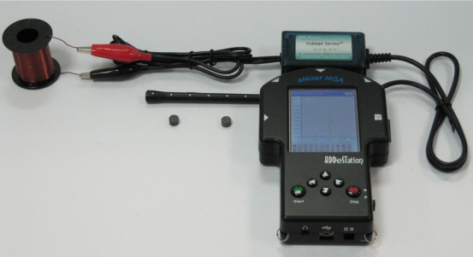

- Datalogger apparatus for collection of data
Phase 3 on Operationalizing: Online Learning by students using Ejs Open Source Alternating Current AC Generator Model Java Applet for concept internalization of Faraday and Lenz’s Laws of Electromagnetic Induction for meaningful functionality. (Figure 4. ).

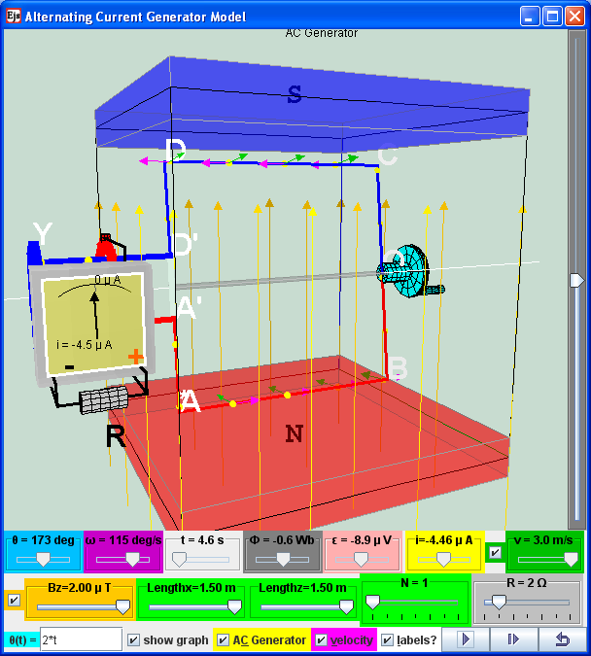
- Screenshot of the AC Generator Simulation Model by
Source: http://www.phy.ntnu.edu.tw/ntnujava/index.php?topic=1275.0
Phase 4 on Integrating: Data logger project featuring Face-to-Face concept application of Faraday and Lenz’s Laws to deduce the value of free fall acceleration to promote meaningful knowledge transfer. Integrating what is learned and applying to different context is an evidence of good science learning.
Essence of the Data logger Project
Learners are to figure out some crucial information with regard to free fall acceleration hidden in an Electromagnetic Induction graph associated with a falling magnet (Figure 5), exploiting the insights into Faraday and Lenz’s Laws obtained through Phases 2 and 3. Next they are to devise a method to deduce the value of free fall acceleration based on the information that they figure out.
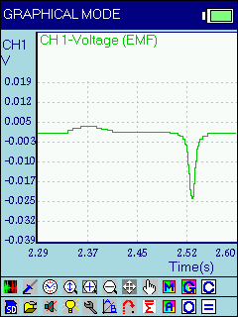

- Screenshot of the Electromagnetic Induction graph associated with falling magnet

Results

Qualitative Interviews with educators
The blended learning exemplar involving face-to-face using data loggers and online learning using simulations was shared at the 2011 JC IPSG platform on 19 January 2011 at ACJC. Besides the positive feedback by the participants verbally after the sharing, emails by participants were received with the following feedback cum request:

“I really enjoyed the presentation by your group yesterday. We are looking into Blended Learning and find some of the ideas you presented can be used immediately. Could I request a pdf copy of your powerpoint slides?”

“I have attended your sharing at yesterday’s IPSG, and I am very keen to know more about your TSOI framework for blended learning. As a future school, I am advocating blended learning for my school, and is looking for a suitable framework for the design of blended learning courses. Would you mind sharing your paper on "Applying TSOI hybrid learning model to enhance blended learning experience in science education"?”

Students’ Interview and Qualitative Feedback

Limitations

Discussions

Conclusion
Based on concept of distributed leadership with different expertise, a tripartite partnership involving a Physics Master Teacher and an Educational Technology Officer from MOE, a NIE Assistant Professor and a Scientist from a local data-logger company designed and developed a blended learning lesson exemplar on a highly abstract topic of Electromagnetic Induction for Junior College teachers and students’ use. The outcome of this tripartite collaboration is a three-prong innovation comprising (a) the creation of real life data-logger experiments to situate scientific concepts in the physical world for face-to-face learning, (b) the customization of computer simulations from the Open-Source-Physics community to facilitate construction of scientific concepts through online learning and (c) the use of the TSOI Hybrid Learning Model as a pedagogical framework for meaningful Blended Learning to integrate the face-to-face learning and online learning.

Acknowledgment
We wish to acknowledge the contributions of Francisco Esquembre, Fu-Kwun Hwang and Wolfgang Christian of the Open Source Physics Community for allowing educators to create free, scientifically appropriate and interactive simulations and curriculum material for physics education.

Reference

Appendix

Worksheet

